Operating Instructions

Parts List
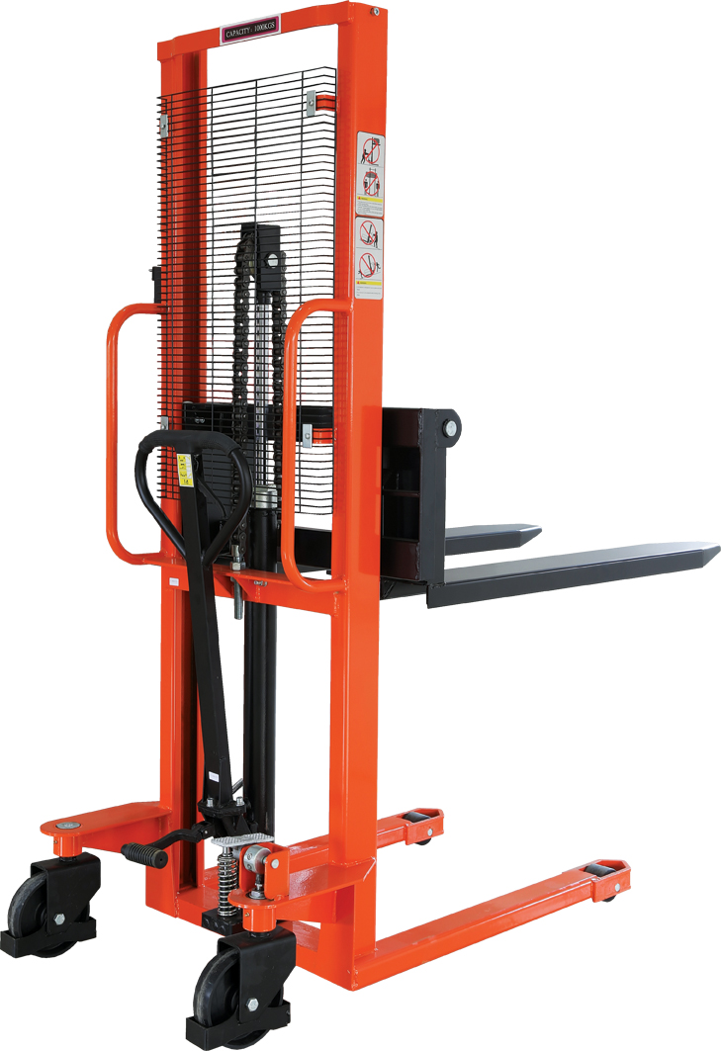

SFH Series Hand Stacker

Note: Owner and operator MUST read and understand this operating instructions before use this pallet truck.

Welcome to use our hand stacker SFH series. Your stacker is made of high quality steel and was designed to give a durable, reliable and easy to use product. For your safety and correct operation, please carefully read this instruction book and warnings on the stacker before using it.

NOTE: All of the information reported herein is based on data available at the moment of printing. The factory reserves the right to modify its own products at any moment without notice and incurring in any sanction. So, it is suggested to always verify possible updates.

- Structural data form
Model |  | SFH1016 | SFH1516 | SFH2016 | SFH1020/25/30 | SFH1520/25/30
Capacity | Kg | 1000 | 1500 | 2000 | 1000 | 1500
Lift Height | mm | 1600 | 1600 | 1600 | 2000/2500/  3000 | 2000/2500/  3000
Fork Length | mm | 900/1000/1150 | 900/1000/1150 | 900/1000/1150 | 900/1000/1150 | 900/1000/1150
Width overall Forks | mm | 320-740/550 | 320-740/550 | 320-740/550 | 320-740/550 | 320-740/550
Overall Height | mm | 1985 | 2060 | 2060 | 1850 | 2060
Min. Fork Height | mm | 85 | 85 | 85 | 85 | 85

- Installation & Adjustment
The stacker have been tested before leaving the factory, Customers can be used directly according to the operation guide.
- Safety Guidance
  - Operator should read all warning signs and instructions here and on the stacker before using it.
  - Do not operate a hand stacker unless you are familiar with it and have been trained or authorized to do so.
  - Do not operate a hand stacker unless you have checked its condition. Give special attention to the wheels, the handle, the guide frame, the pilot wheel, the doorframe, etc.
  - Do not use it on a slopping ground.
  - Do not take up any people on the forks.
  - The operator had better take on gloves for labor protecting.
  - When the goods have been transported or lifted, all people should be away form the forks for 600mm.
  - Do not load over maximum capacity.
  - The weight of goods should be distributed on the two forks, do not use only one fork. The center of gravity of goods should be in the center of two forks.
  - People forbid standing under the forks.
  - Do not move the hand stacker when the goods are lifted to the height more than 300mm.
  - At other special condition or place, the operator should be carefully to operate the hand stacker.

- Maintenance
  - Hydraulic oil
Please check the oil level every six months. The oil can be hydraulic oil: ISO VG32, its viscosity should be 32cSt at 40ºC, total volume is about 2.0lt.
  - Daily check and maintenance
It is necessary to check the hand stacker daily. Special attention should be paid to the wheels, the axles, as thread, rags, etc., it may block the wheels, the fork and the mast should be checked, too. The forks should be unloaded and lowered in the lowest position when the job is over.
  - Lubrication
Use motor oil or grease to lubricate all movable parts.
  - Remove the air
The air may enter the hydraulic pump during the transportation after the customer buys it. It will cause the piston rod to fail to keep up the raised height. The air can be removed in the following way: pull the control handle (FS107) up and move handle (FS110) up and down for several times.

- TO Adjust release device
On the draw-bar of this hand stacker, you can find the control handle (FS107) which can be regulated in three positions: LOWER = to lower the forks; NEUTRAL = to move the load, and LIFT = to raise the fork. These three positions have been pre-posited at the factory. If however they have been changed, you can adjust according to following step:
4.1 If the forks elevate while pumping in the NEUTRAL position, turn the adjusting nut (FS116) on the adjusting bolt (FS115) clockwise or turn the adjusting screw (F229) clockwise until pumping action does not raise the forks and the NEUTRAL position functions properly.
4.2 If the forks descend while pumping in the NEUTRAL position, turn the nut (FS116) or the screw (F229) counter-clockwise until the forks do not lower.
4.3 If the forks do not descent when the control handle (FS107) is in the LOWER position, turn the nut (FS116) or the screw (F229) clockwise until raising the control handle (FS107) lowers the forks. Then check the NEUTRAL position according to item 4.1 and 4.2 to be sure the nut (FS116) and the screw (F229) is in the proper position.
4.4 If the forks do not elevate while pumping in the LIFT position, turn the nut (FS116) or the screw (F229) counter-clockwise until the forks elevate while pumping in the LIFT position. Then check the LOWER and NEUTRAL position according to item 4.1, 4.2 and 4.3.
- TROUBLES SHOOTING
No | Trouble | Clause | Fixing Methods
1 | The forks can not be up the max. height. | - The hydraulic oil is not enough. | - Pour in the oil.
2 | The forks can not be lifted up. | - Without hydraulic oil.  - The oil has impurities.  - The nut (FS116) is too high or the screw (F229) is too close, keep the pumping valve open.  - Air comes into the hydraulic oil. | - Fill in the oil.  - Change the oil.  - Adjust the nut (FS116) or the screw (F229) .(see item 4.4)  - Banish the air.(see item 3.4)
3 | The forks can not be descended. | - The piston rod(F248) or pump body(F225) or the mast (F346) is deformed resulting from loading slanting to one side or over-loading.  - The fork was kept in the high position for long time with piston rod bared to arise in rusting and jamming of the rod.  - The adjusting nut (FS116) or the screw (F229) is not in the correct position.  - The rollers (F327) are not lubricated. | - Replace it.  - Keeping the fork in the lowest position if not using, and pay more attention to lubricate the rod.  - Adjust the nut (FS116) or the screw (F229). (see item 4.3)  - Lubricate its.
4 | Leaks | - Sealing parts worn or damaged.  - Some part cracked or worn into small. | - Replace with the new one.  - Replace with the new one.
5 | The fork descends without the release valve worked. | - The impurities in the oil cause the release valve to be unable to close tight.  - Some parts of hydraulic system is cracked or bored.  - Air comes into the oil.  - Sealing parts worn or damaged.  - The adjusting nut (FS116) or the screw (F229) is not in the correct position. | - Replace with new oil.  - Inspect and replace the waste parts.  -Banish the air. (See item 3.4)  - Replace with the new one.  - Adjusting the nut (FS116) or the screw (F229). (See item 4.2)

NOTE: DO NOT ATTEMP TO REPAIR THE PALLET TRUCK UNLESS YOU
ARE TRAINED AND AUTHORIZED TO DO SO.
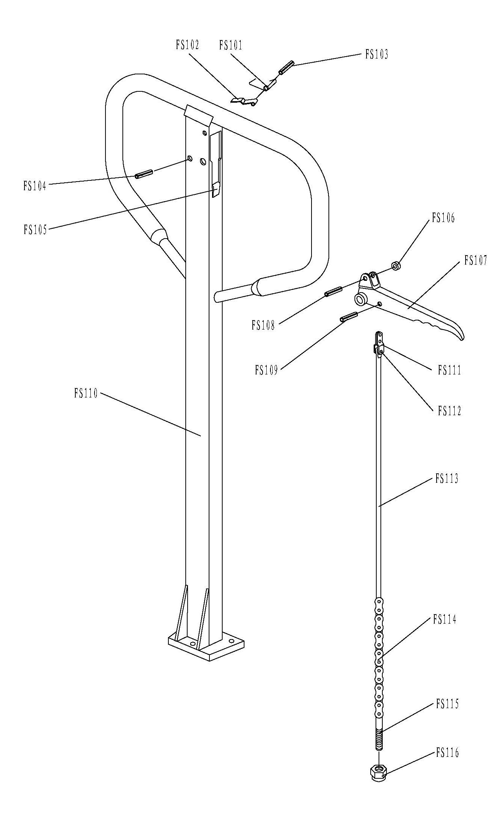

Handle Part List
No. | Description | Qty. | No. | Description | Qty.
FS101 | Spring | 1 | FS109 | Elastic Pin | 1
FS102 | Bldae Spring | 1 | FS110 | Handle | 1
FS103 | Elastic Pin | 1 | FS111 | Pull Board | 1
FS104 | Elastic Pin | 1 | FS112 | Pin | 1
FS105 | Rubber Washer | 1 | FS113 | Release Rod | 1
FS106 | Roller | 1 | FS114 | Chain | 1
FS107 | Control Handle | 1 | FS115 | Adjusting Bolt | 1
FS108 | Elastic Pin | 1 | FS116 | Adjusting Nut | 1
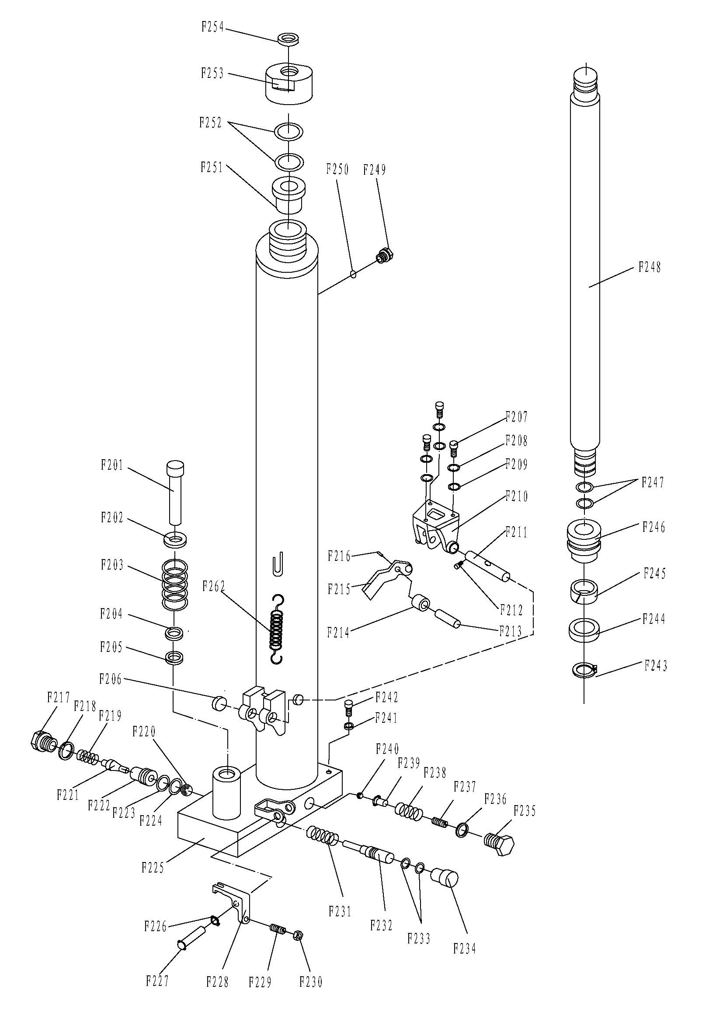

Pump Part List for SFH1016;1516;2016;1020;1025;1030;
No. | Description | Qty. | No. | Description | Qty.
F201 | Pump Piston Rod | 1 | F229 | Screw | 1
F202 | Spring Washer | 1 | F230 | Nut | 1
F203 | Spring | 1 | F231 | Spring | 1
F204 | Dust Ring | 1 | F232 | Strike Pin | 1
F205 | Seal | 1 | F233 | O-Ring | 2
F206 | Bushing | 2 | F234 | Dust Catcher | 1
F207 | Screw | 3 | F235 | Cover with Screw | 1
F208 | Washer | 3 | F236 | Seal Washer | 1
F209 | Spring Washer | 3 | F237 | Adjusting Bolt | 1
F210 | Bracket | 1 | F238 | Spring | 1
F211 | Shaft for Roller | 1 | F239 | Spring Seat | 1
F212 | Screw | 1 | F240 | Steel Ball | 1
F213 | Shaft | 1 | F241 | Seal Washer | 1
F214 | Pressure Roller | 1 | F242 | Screw | 1
F215 | Lever of Pedal | 1 | F243 | Locking Ring | 1
F216 | Elastic Pin | 1 | F244 | Y-Ring | 1
F217 | Screw | 1 | F245 | Support Ring | 1
F218 | Seal Washer | 1 | F246 | Piston | 1
F219 | Spring | 1 | F247 | O-Ring | 2
F220 | Steel Ball | 1 | F248 | Lifting Piston Rod | 1
F221 | Valve Spindle of Pump | 1 | F249 | Screw | 1
F222 | Seat of pump Valve | 1 | F250 | Screw | 1
F223 | O-Ring | 1 | F251 | Conduit | 1
F224 | Washer | 1 | F252 | O-Ring | 2
F225 | Body of Pump | 1 | F253 | Cover with Screw | 1
F226 | Locking Ring | 1 | F254 | Dust Ring | 1
F227 | Elastic Pin | 1 | F262 | Spring | 2
F228 | Lever Plate | 1
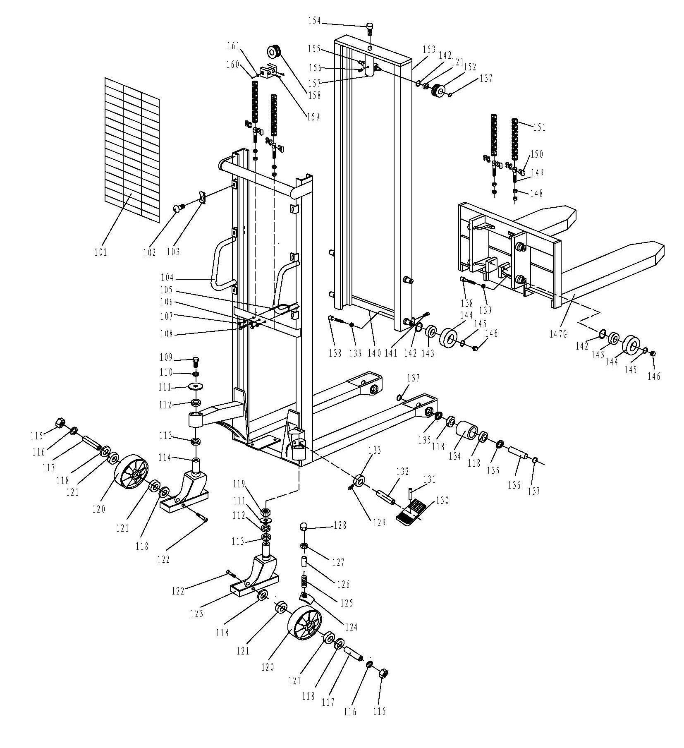

Mast Part List for SFH1020;1025;1030;
No. | Description | Qty. | No. | Description | Qty.
101 | Reticulation | 1 | 132 | Shaft | 1
102 | Screw | 6 | 133 | Cam | 1
103 | Clip | 6 | 134 | Washer | 4
104G | Mast | 1 | 135 | Shaft of Roller | 2
105 | Hoop | 1 | 136 | Roller | 2
106 | Nut | 3 | 137 | Locking Ring for Axle | 14
107 | Nut | 2 | 138 | Screw | 8
108 | Bolt | 1 | 139 | Nut | 8
109 | Bolt | 1 | 140 | Linking Plate | 1
110 | Elastic Washer | 1 | 141 | Screw | 4
111 | Washer | 1 | 142 | Locking Ring for Hole | 4
112 | Bearing | 2 | 143 | Bearing | 8
113 | Bearing | 2 | 144 | Roller | 4
114 | Frame of Wheel | 1 | 145 | Locking Ring | 8
115 | Nut | 2 | 146 | Steel Ball | 8
116 | Elastic Washer | 2 | 147G | Fixed Fork | 4
117 | Axle | 2 | 148 | Nut | 4
118 | Washer | 8 | 149 | Bolt | 2
119 | Nut | 1 | 150 | Connect | 2
120 | Wheel | 2 | 151 | Chain | 2
121 | Bearing | 8 | 152 | Roller for Chain | 2
122 | Screw | 2 | 153 | Inner Mast | 1
123 | Frame of Wheel with Brake | 1 | 154 | Screw | 4
124 | Brake Plate | 1 | 155 | Axle | 4
125 | Spring | 1 | 156 | Elastic Pin | 1
126 | Cover | 1 | 157 | Frame | 4
127 | Nut | 1 | 158 | Wheel | 2
128 | Nut | 1 | 159 | Bolt | 4
129 | Screw | 1 | 160 | Axle | 2
130 | Pedal | 1 | 161 | Locking Ring for Hole | 2
131 | Elastic Pin | 1
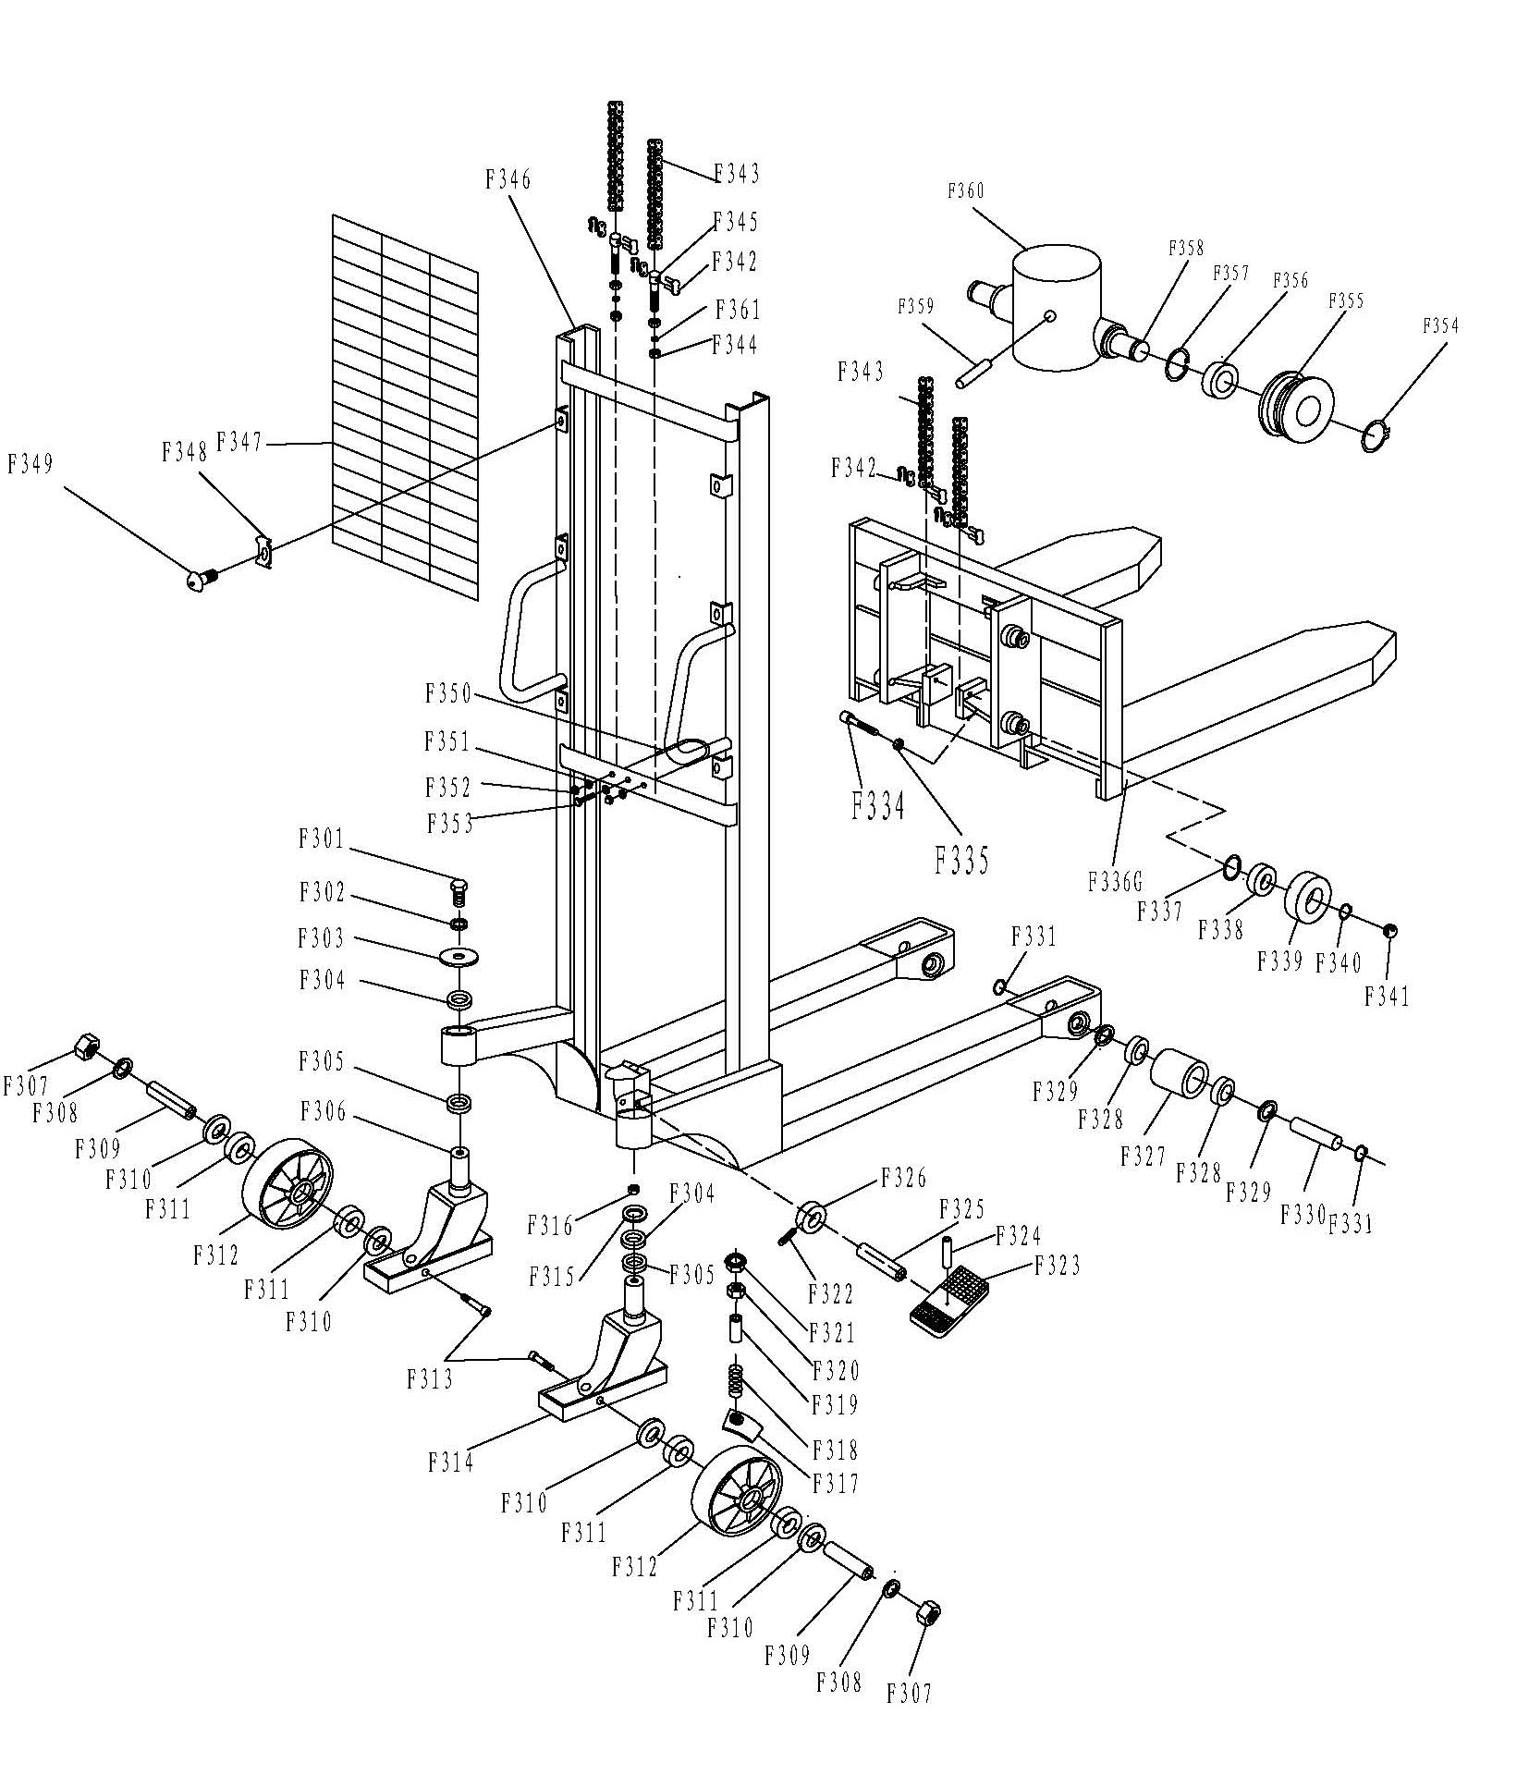
Mast Part List for SFH1016;1516;2016;
No. | Description | Qty. | No. | Description | Qty.
F301 | Bolt | 1 | F331 | Locking Ring | 4
F302 | Elastic Washer | 1 | F334 | Bolt | 4
F303 | Washer | 1 | F335 | Nut | 4
F304 | Bearing | 2 | F336 | Fork | 2
F305 | Bearing | 2 | F337 | Locking Ring | 4
F306 | Frame of Wheel | 1 | F338 | Bearing | 4
F307 | Nut | 2 | F339 | Roller | 4
F308 | Elastic Washer | 2 | F340 | Locking Ring | 4
F309 | Axle of Wheel | 2 | F341 | Steel Ball | 4
F310 | Cover | 4 | F342 | Connect | 2
F311 | Bearing | 4 | F343 | Chain | 2
F312 | Wheel | 2 | F344 | Nut | 2
F313 | Screw | 2 | F345 | Bolt | 1
F314 | Frame of Wheel With Brake | 1 | F346 | Mast | 1
F315 | Washer | 1 | F347 | Reticulation | 1
F316 | Nut | 1 | F348 | Clip | 6
F317 | Brake Plate | 1 | F349 | Screw | 6
F318 | Spring | 1 | F350 | Hoop to Holding Pump | 1
F319 | Cover | 1 | F351 | Nut | 3
F320 | Nut | 1 | F352 | Nut | 2
F321 | Nut | 1 | F353 | Bolt | 1
F322 | Screw | 1 | F354 | Locking Ring | 2
F323 | Footplate | 1 | F355 | Roller for Chain | 2
F324 | Elastic Pin | 1 | F356 | Bearing | 2
F325 | Pin | 1 | F357 | Locking Ring | 2
F326 | Cam | 1 | F358 | Axle | 1
F327 | Roller | 2 | F359 | Elastic Pin | 1
F328 | Bearing | 4 | F360 | Frame | 1
F329 | Cover | 4 | F361 | Elastic Washer | 3
F330 | Axle of Loading Roller | 2
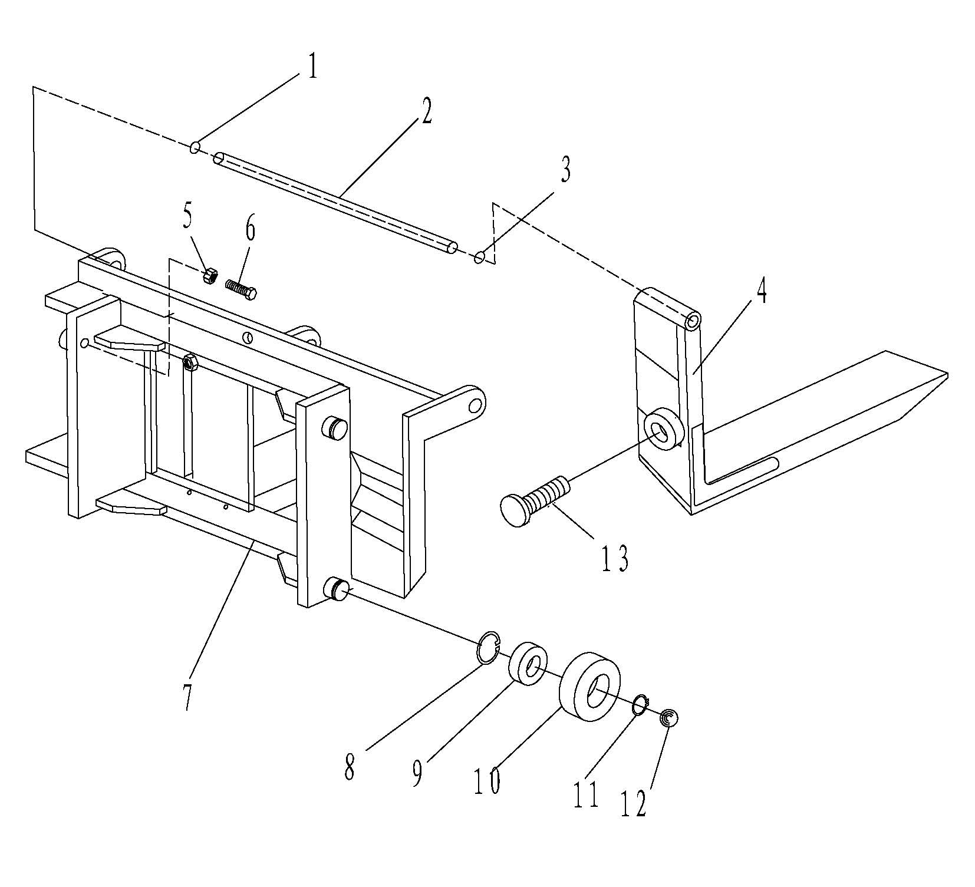
ADJUSTED FORK LIST
No. | Description | Qty.
1 | Locking Ring | 1
2 | Long Axle | 1
3 | Locking Ring | 1
4 | Adjusting Fork | 2
5 | Nut | 4
6 | Bolt | 4
7 | Frame Carriage | 1
8 | Locking Ring for Hole | 4
9 | Bearing | 4
10 | Roller | 4
11 | Locking Ring | 4
12 | Steel Ball | 4
13 | Bolt | 2

