Instruction Manual
Aluminum lift table
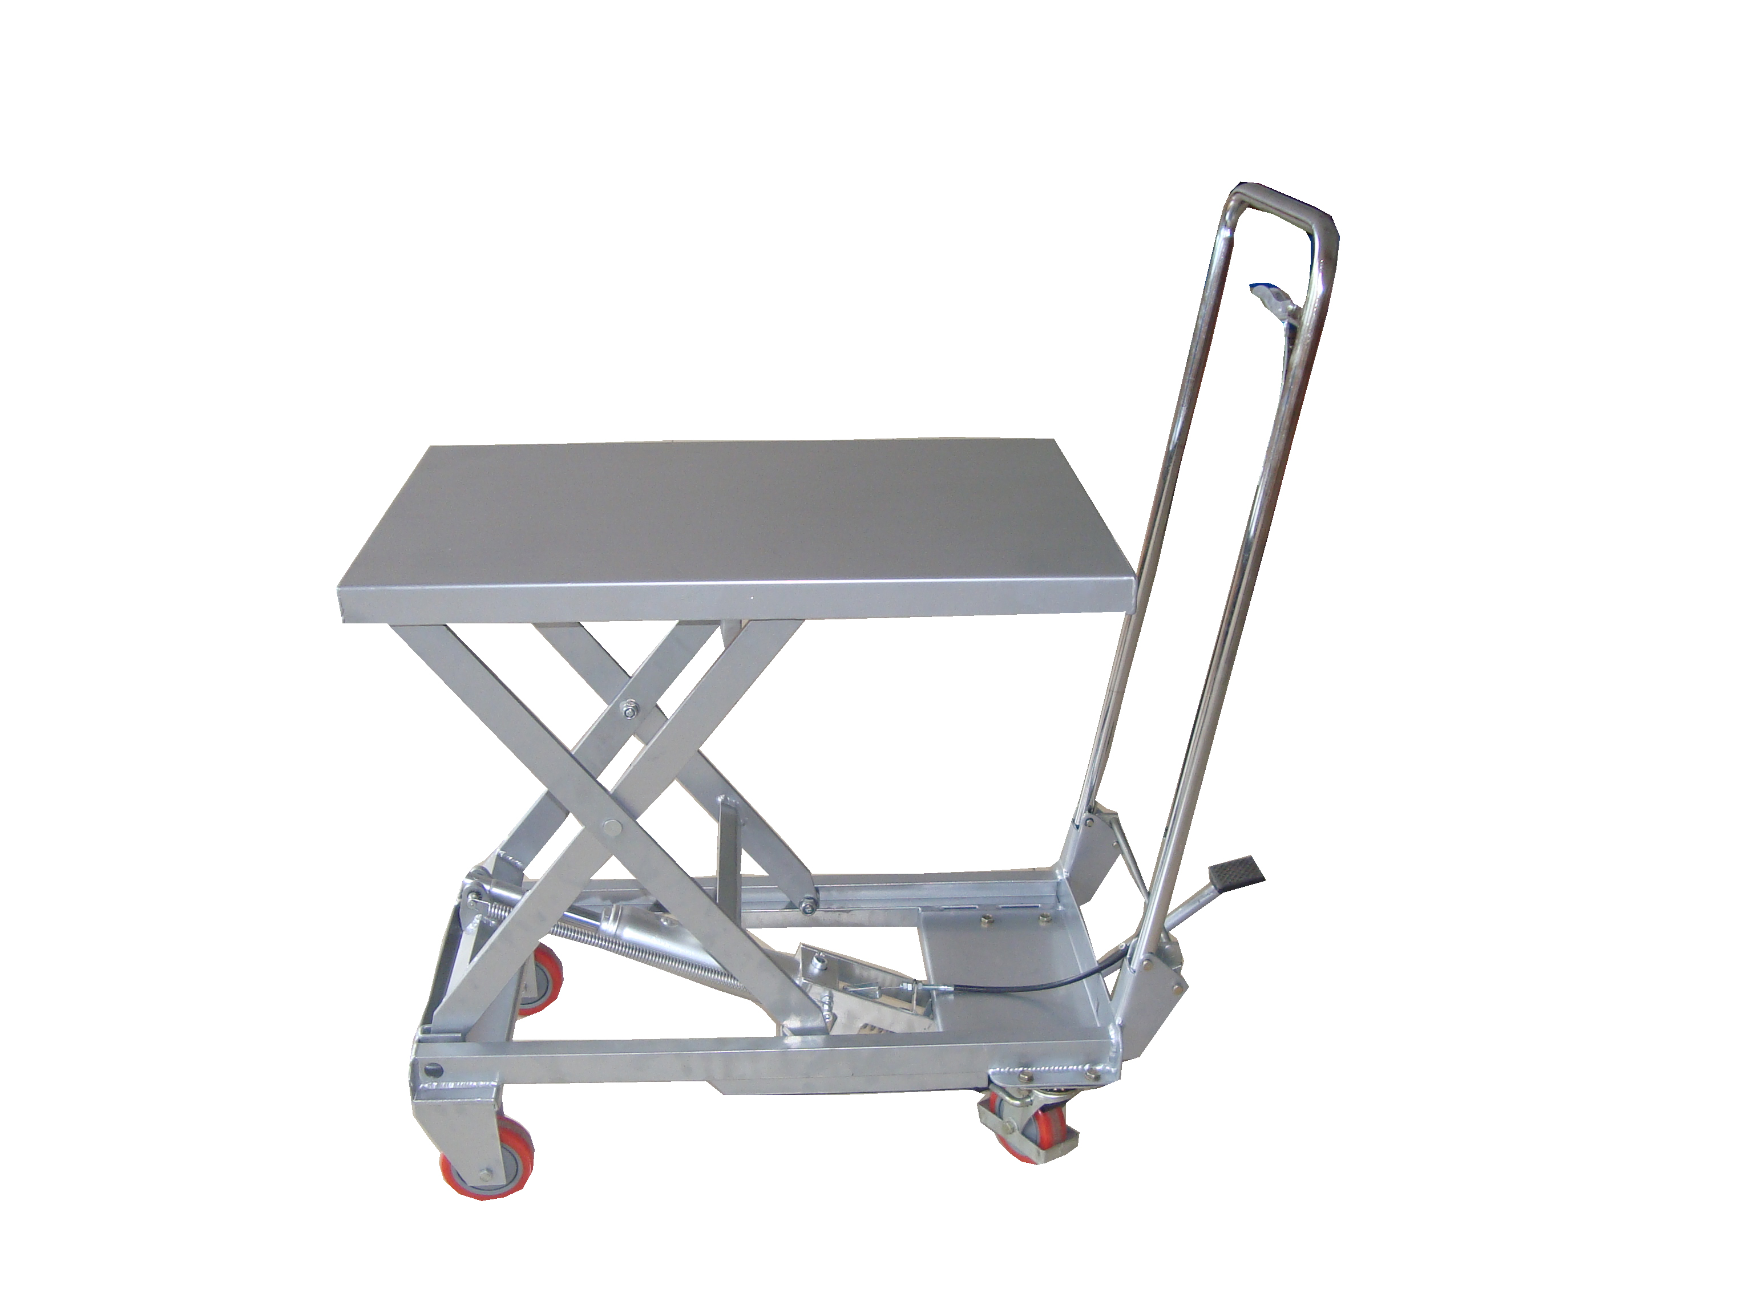

Note: Owner/Operator must read and understand this instruction manual before using the lift table.

Operation and Service Manual
BEFORE OPERATING THE LIFT TABLE, READ THIS MANUAL CAREFULLY AND UNDERSTAND COMPLETELY. KEEP THIS MANUAL ON FILE FOR FUTURE REFERENCE. IF THIS IS LOST, PLEASE CONTACT YOUR LOCAL SUPPLIER FOR A NEW COPY. ALSO, IF THE WARNING/CAUTION DECAL ON THE UNIT IS LOST, PLEASE CONTACT YOUR LOCAL SUPPLIER FOR A NEW DECAL.
NOTE: On this manual, WARNING means the danger which can lead to death or serious injury. CAUTION means the danger which can lead to slight injury or property damage.
- WARNING
1.DO NOT put foot or hand in scissors mechanism.
2.DO NOT allow other person to stand in front of or behind lift table when it is moving.
3.DO NOT move lift table when table is in raised position. Load could fall down.
4.DO NOT enter under table.
5.DO NOT overload lift table.
6.DO NOT put foot in front of rolling wheels. Injury could result.
7.WATCH difference and hardness of floor level when moving lift table. Load could fall down.
8.DO NOT use lift table on slope or inclined surface, lift table may become uncontrollable and cause danger.
9.DO NOT lift people. People could fall down and suffer severe injury.
- CAUTION
1.Read this operation manual carefully and understand completely before operating lift table. Improper operation could cause danger.
2.This lift table is a movable lifter designed to lift or lower rated load on table. NO NOT use lift table for other purpose than its intended use.
3.DO NOT allow person to operate lift table who does not understand its operation.
4.DO NOT lower table too fast. Load could fall down and result damage.
5.KEEP watching the condition of load. Stop operating lift table if load becomes unstable.
6.Brake lift table when load slide off form the table.
7.Load centre of gravity should be located the centre area of the table.
8.DO NOT use lift table with unstable, unbalanced loosely stacked load.
9.Do maintenance and routine check according to service instructions.
10. DO NOT modify lift table without manufacturer’s written consent.
11. REMOVE load from table and use safety stopper to prevent table from lowering when servicing lift table.
12. The lift table should be used in a dry environment and normal temperature.

- DAILY INSPECTION
Daily inspection is effective to find the malfunction or fault on lift table. Check lift table on the following points before operation.
CAUTION
DO NOT use lift table if any malfunction or fault is found.
- Check for scratch, bending or cracking on the lift table.
- Check if there is any oil leakage from the cylinder.
- Check the vertical creep of the table.
- Check the smooth movement of the wheel.
- Check the function of brake.
- Check if all the bolts and nuts are tightened firmly.

- OPERATING LIFTTABLE
4-1. How to use the brake.

CAUTION
Brake lift table when not moving it in order to prevent sudden movement.

The brake is equipped with the swivel caster on the right side.
- Braking the wheel, press the brake pedal.
- Releasing the brake, lift up the brake pedal.
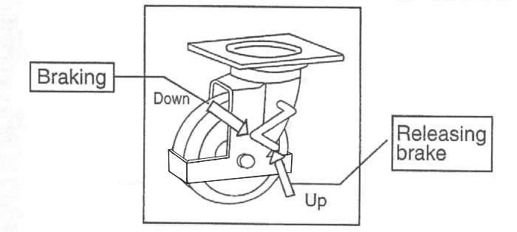

4-2 Lifting the table

WARNING
  - DO NOT overload lift table, stay within its rated capacity.
  - Load must be distributed on at least 80% of table area.
Press the lifting pedal several times until the table reaches desired position.
The table does not elevate after reaching the highest position even if the lifting pedal is pressed.
The table lowers slightly after reaching the highest position.

4-3. Lowering table

WARNING
DO NOT put foot or hand in scissors mechanism.

Pull the lowering down and table lowers.
- Specifications
Model | Capacity  (kg) | Table  (mm) | Table  Height(mm) | Stroke | L×W×H  (mm) | Wheel  (mm)  φ | Weight  (kg)
BSA10 | 100 | 700×450 | 265-755 | 490 | 910×450×1020 | 100 | 23

- Service instruction
6.1-1. Lubricate each point described below every month:
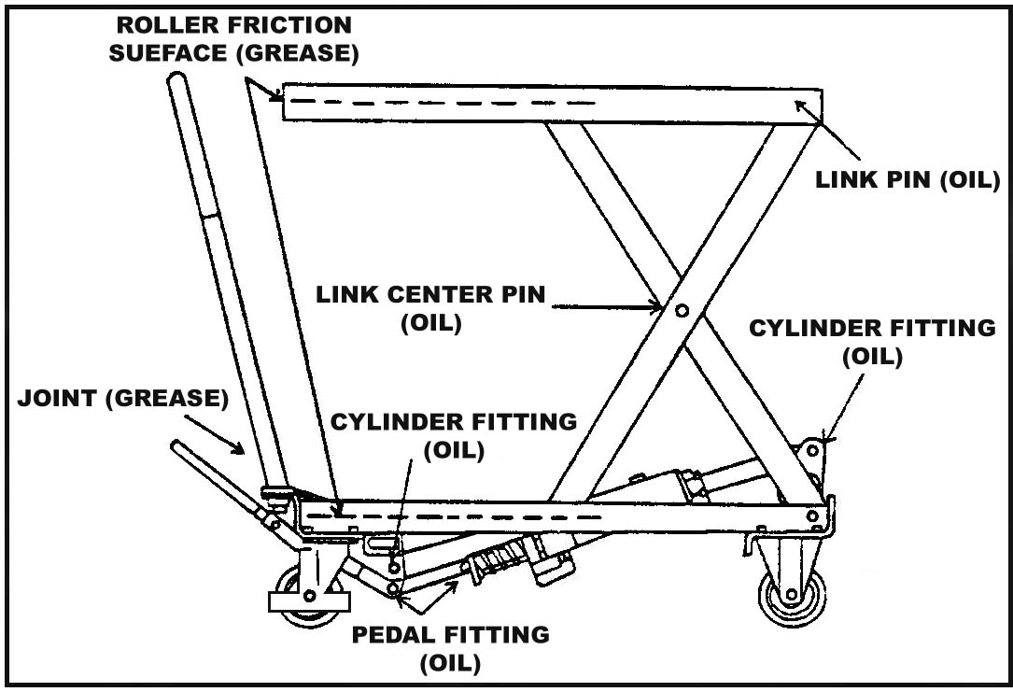
6.2.Change hydraulic oil every 12 months.
Lubricating Points
- Fitting of cylinder……Oil
- Roller friction surface……Grease
- Link Pin ……Oil
- Pedal fitting point……Oil
- Link center pin……Oil
- Joint……Grease
- Grease nipple……Grease
- Hydraulic circuit

- Hydraulic Circuit
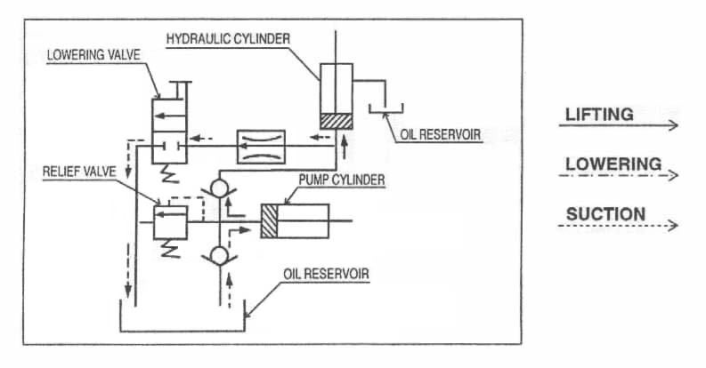

NO. | DESCRIPTION | Qty | NO. | DESCRIPTION | Qty
1 | Table pair | 1 | 33 | screw | 1
2 | Pin | 2 | 34 | Snap ring | 1
3 | Washer | 6 | 35 | Hold yoke L | 1
4 | Pin | 4 | 36 | Lock nut | 1
5 | Scissors 1 | 1 | 37 | Washer | 3
6 | Snap ring | 7 | 38 | Valve arm | 1
7 | Lock nut | 4 | 39 | screw | 2
8 | Guide roller | 4 | 40 | Spacer | 1
9 | Link Pin | 4 | 41 | screw | 1
10 | Washer | 2 | 42 | Hold yoke R | 1
11 | Lock nut | 2 | 43 | screw | 1
12 | Scissors 2 | 1 | 44 | Pin | 1
13 | Frame pair | 1 | 45 | Pin | 1
14 | Lock nut | 3 | 46 | Pin | 1
15 | wheel | 4 | 47 | spring | 1
16 | Spring washer | 1 | 48 | Spring seat | 1
18 | screw | 4 | 49 | Retain Ring | 1
19 | Steering wheel seat | 2 | 50 | Link rod | 2
20 | wheel bracket-for protection | 2 | 51 | Spacer | 1
21 | Nut | 9 | 52 | screw | 1
22 | Spring washer | 14 | 53 | Pedal holder | 1
23 | Washer | 22 | 54 | screw | 1
24 | screw | 8 | 55 | Rubber bushing | 1
25 | Pin | 4 | 56 | Pedal Pair | 1
26 | Spacer | 2 | 57 | Pedal rubber | 1
27 | Snap ring | 4 | 58 | Handle | 1
28 | Handle lock spring R | 1 | 59 | Release Rod | 1
29 | Handle lock spring L | 1 | 60 | screw | 1
30 | Lock bar | 1 | 61 | Spring washer | 1
31 | spring | 1 | 62 | Nut | 1
32 | Pin | 1 | 63 | Control link | 4
100 | Pump Assembly
200 | Handle Assembly |  | 58-63
300 | Steering wheel Assembly |  | 14-20

NO. | DESCRIPTION | Qty | NO. | DESCRIPTION | Qty
101 | Cylinder Nut r | 1 | 121 | O ring | 1
102 | O ring | 1 | 122 | screw | 1
103 | Seal Ring | 1 | 123 | Seal Ring | 1
104 | Oil Tank | 1 | 124 | Pump | 1
105 | Oil Plug | 1 | 125 | Y-Ring | 1
106 | Piston Rod | 1 | 126 | O ring | 1
107 | O-Ring Retaining | 1 | 127 | Back-Up Ring | 1
108 | O ring | 1 | 128 | Plunger | 1
109 | Cylinder | 1 | 129 | O ring | 1
110 | Seal Ring | 1 | 130 | Back-Up Ring | 1
111 | Seal Ring | 1 | 131 | O ring | 1
112 | Valve Block | 1 | 132 | Snap ring | 1
113 | Ball | 2 | 133 | Pin | 1
114 | Ball | 1 | 134 | spring | 1
115 | Seal Ring | 1 | 135 | Spacer | 1
116 | screw | 1 | 136 | spring | 1
117 | Ball | 1 | 137 | O ring | 1
118 | Ball Seat | 1 | 138 | Release Rod | 1
119 | Spring | 1 | 139 | Spacer | 1
120 | screw | 1
 | Seal kit |  | 102,103,105,107,108,110,111,115,121,123,  125,126,127,129,130,131 ,137

VERSION ONE 4/2012

