Instruction Manual

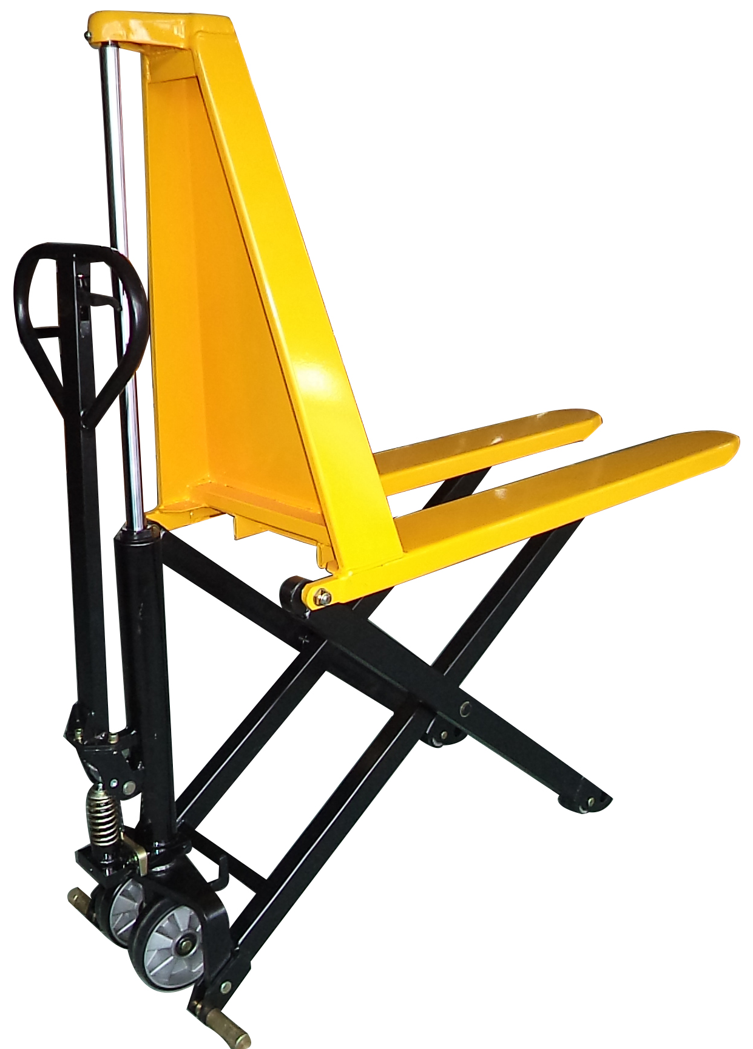
HIGH LIFT PALLET TRUCK

CAPACITY: 1000KGS
Note: Owner/Operator must read and understand this
instruction manual before operating the truck.

RevB： 08/2018

Specifications
Model | HLT1CM-540 | HLT1CM-685
Rated capacity | 1000 kgs
Lifting height | 800 mm
Height of lowerd fork | 85 ±2 mm
Fork length | 1170 mm
Width across fork | 540 mm | 685mm
Steer wheel | Ø180×55mm
Front load roller | Ø75×50mm
Pump times | Fast: 28 Slow: 70
Descending speed | ∠0.1 mm/second
N.W. | 109 kgs | 115kgs
NOTE:
Two speeds (quick and slow) can be automatically changed while load is more than 150kgs.

Safety Instructions
- The truck shall be used in accordance with the instruction manual.
- Don’t put hand & foot underneath the fork at any time.
- Don’t work on a slope surface.
- Quick lifting is prohibited for load of more than 150kgs. Any manipulation of the pressure relief valve is strictly prohibited. All assembling, adjusting and maintenance shall only be performed by qualified people.
- Load should be put on the fork center. Side-load is strictly prohibited.
- The truck shall not be used to transport persons.
- It is recommended for the driver to wear security shoes.
- No modifications shall be carried out which adversely affect the compliance of the truck with prEN 1757-4.

Installation & Adjustment
- Screw (Part No.329)
- To prevent oil-leaking from oil tank during transportation, Air Screw (Part No.329) is replaced by Oil-sealing Screw in factory. But it has to be replaced back when you put this truck into use.
- How to change: Take off Oil-sealing Screw, then screw Air Screw in, thus keep oil tank always connecting with atmosphere.
- Handle
During transportation, the handle is disassembled from the truck and packed separately. It has to be assembled back and adjusted properly and carefully before use.

Handle installation
- Take off screw (108) & washer(109).
- Assemble the handle on the Handle Base(101) with 3 pieces of screw (108) & washer(109).
- Press the handle, and take off the hooked plate .

B. Handle adjustment
- There are 3 different positions with different functions for the Release Lever (Part No. 117).
Release Lever(No.117)

Position 3
Position 2
Position 1

Picture 1
Position 1: Lifting for fork
Position 2: Neutral for fork
Position 3: Descending for fork
- Test different functions by putting the Release Lever in 3 different positions respectively. If it does not function properly, then adjusting Lock Nut (No.124) by following process.
See Picture 2.

Problems | Turning direction of adjusting Nut
Fork not lifted up | - (clockwise)
Fork not lowering down | + (Counter-Clockwise)
Picture 2
3.How to release the air from the pump.
See picture 3

When pushing the handle down, the fork can’t be lifted instantly. Please loosen the Screw (No.322) on the pump while pushing the handle down slowly to release the air from the pump. Then tighten the screw.

4.When to add oil
See Picture 3
If the fork can’t be pumped up to its rated highest position, you may have to add hydraulic oil into the oil tank. The hydraulic fluid to be used must have a quality of ISO VG22 or equivalence. Mixing of different fluids is prohibited!

TROUBLE SHOOTING GUIDE
Items | Symptom | Possible cause | Aliments
1 | Fork can not be pumped up | - Low oil level in oil tank.  - Exist air in the hydraulic system.  - Pendulum arm nut is not adjusted properly. | - Add proper hydraulic oil.  - Fast operating the handle for several times. Bleed the system.  - Adjust pendulum arm screw. (See Picture 2)
2 | Fork can’t be released down | - Fork blocked.  - Pendulum arm nut not adjusted properly. | - Check and remove the block.  - Adjust pendulum arm nut properly.  (See Picture 2)
3 | Fork can’t be pumped up to rated highest position. | Oil is not enough. | Add hydraulic oil.  (See Picture 3)

Spare parts list

Breakdown Drawing of Draw-bar

PARTS LIST OF DRAW-BAR

NO. | Description | Qty. | NO. | Description | Qty.
101 | Handle Seat | 1 | 113 | Blade Spring | 1
102 | Bush | 2 | 114 | Spring | 1
103 | Axle with Hole | 1 | 115 | Elastic Pin | 1
104 | Spacer | 2 | 116 | Elastic Pin | 1
105 | Roller | 1 | 117 | Control Handle | 1
106 | Bush | 2 | 118 | Roller | 1
107 | Pin | 1 | 119 | Elastic Pin | 1
108 | Spring lock washer | 3 | 120 | Release Rod | 1
109 | Socket cap screw | 3 | 121 | Chain connector | 2
110 | Draw - bar | 1 | 122 | Chain | 1
111 | Stop Rubber | 1 | 123 | Adjusting Bolt | 1
112 | Elastic Pin | 1 | 124 | Adjusting Nut | 1

Breakdown Drawing of Optional Draw-bar

PARTS LIST OF OPTIONAL DRAW-BAR

NO. | Description | Qty. | NO. | Description | Qty.
101 | Handle Seat | 1 | 113D | Cover | 1
102 | Bush | 2 | 114D | Ball | 1
103 | Axle with Hole | 1 | 115D | Spring | 1
104 | Spacer | 2 | 116D | Pin | 1
105 | Roller | 1 | 117D | Controlling Handle | 1
106 | Bush | 2 | 118D | Handle | 1
107 | Pin | 1 | 120D | Release Rod | 1
108 | Spring lock washer | 3 | 121 | Chain connector | 3
109 | Socket cap screw | 3 | 122D | Chain | 1
110D | Draw - bar | 1 | 123 | Adjusting Bolt | 1
111D | Pin | 4 | 124 | Adjusting Nut | 1
112D | Screw | 8

Breakdown Drawing of Frame（Ⅰ）
PARTS LIST of FRAME（Ⅰ）
NO. | Description | Qty. | NO. | Description | Qty.
201 | Fork Frame | 1 | 213 | Bushing | 2
202 | Bolt | 1 | 214 | Spring Lock Washer | 2
203 | Locknut | 1 | 215 | Nut | 2
204 | Locknut | 2 | 216 | Knighthead | 2
205 | Plain Washer | 4 | 217 | Bushing | 2
206 | Spacer | 2 | 218 | Chassis Frame | 1
207 | Plain Washer | 8 | 219 | Circlip for Shaft | 4
208 | Pin | 2 | 220 | Shaft of Roller | 2
209 | Circlip for Shaft | 12 | 221 | Bearing | 4
210 | Bushing | 2 | 222 | Roller | 2
211 | Pin | 2 | 223 | Steel Roller | 4
212 | Eccentric Spindle | 2

Breakdown Drawing of Pump

PARTS LIST OF PUMP

NO. | Description | Qty. | NO. | Description | Qty.
301 | Pin | 1 | 326 | Ball Seat | 1
302 | Spring Seat | 1 | 327 | Steel Ball | 1
303 | Spring | 1 | 328 | Pump Housing | 1
304 | Dust Ring | 1 | 329 | Air Screw | 1
305 | Y-Ring | 1 | 330 | Steel Ball 5 | 1
306 | Pump Cylinder | 1 | 331 | Cone Valve | 1
307 | Piston | 1 | 332 | Spring | 1
308 | Steel Ball 3 | 2 | 333 | O-Ring | 1
309 | Spring | 2 | 334 | Screw | 1
310 | O-Ring | 1 | 335 | Plain Washer | 1
311 | Spring | 1 | 336 | Throttle-Slice | 1
312 | Steel Ball 6 | 1 | 337 | Valve Set | 1
313 | O-Ring | 1 | 338 | Piston Ring | 1
314 | Valve Seat | 1 | 339 | Retaining Ring | 1
315 | O-Ring | 2 | 340 | Piston Rod | 1
316 | Cylinder | 1 | 341 | Nylon Gasket | 1
317 | Spring-type Straight Pin | 1 | 342 | O-Ring | 1
318 | Spring | 1 | 343 | Y-Ring | 1
319 | O-Ring | 1 | 344 | Check Ring | 1
320 | Release Indicator | 1 | 345 | Cylinder Nut | 1
321 | Pendulum Arm | 1 | 346 | O-Ring | 1
322 | Oil-sealing Screw | 2 | 347 | Dust Ring | 1
323 | O-Ring | 2 | 348 | Steel Ball 19 | 1
324 | Screw | 1 | 349 | PU Rod | 1
325 | Spring | 1

VESION ONE

