WARNING
Do not use the stacker before
reading and understanding this operating instructions.

NOTE!
Keep for future reference.



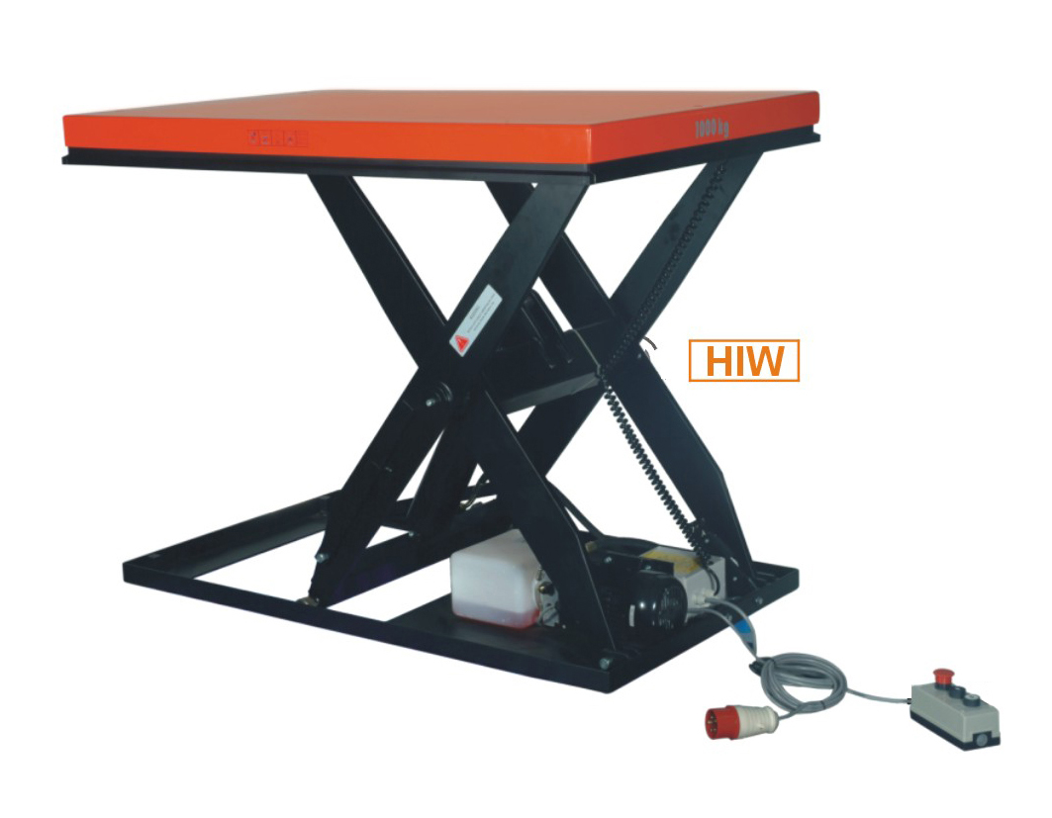

Operating Instructions / Parts List
HIW ELECTRIC PLATFORM

ATTENTION:

- Environmentally hazardous waste, such as batteries and electronics, will have a negative effect on the environment, or health, if handled incorrectly.

- The waste packages should be sorted and put into solid dustbins according to the materials and be collected disposal by local special environment protection bureau. To avoid pollution, it’s forbidden to throw away the wastes randomly.

- To avoid leaking during the use of the products, the user should prepare some absorbable materials (scraps of wooden or dry duster cloth) to absorb the leaking oil in time. To avoid second pollution to the environment, the used absorbable materials should be handed in to special departments in terms of local authorities.

NOTE: All of the information reported herein is based on data available at the moment of printing. We reserve the right to modify our own products at any moment without notice and incurring in any sanction. So, it is suggested to always verify possible updates.

Welcome to use our electrical lift table. This lift table is made of high quality steel and is designed to give a durable, reliable and easy to use. For your safety and correct operation, please carefully read this instruction and warnings on the lift table before using it.

- SPECIFICATIONS

TYPE |  | HIW50 | HIW100 | HIW200 | HIW300
Capacity | kg | 500 | 1000 | 2000 | 3000
Max. height | mm | 1010 | 1010 | 1010 | 1020
Min.height | mm | 190 | 190 | 190 | 220
Dimension of the table | mm | 1300x800 | 1300x800 | 1300x800 | 1300x800
Lifting speed | S | 15 | 26 | 40 | 26
Lower speed | S | 13 | 20 | 30 | 22
Pump electric current | L/min | 3 | 3 | 3 | 5
Oil tank | L | 2 | 2 | 3 | 3
Pump station |  | AC3x400,  1100W | AC3x400V,  1100W | AC3x400V,  1500W | AC3x400V  2200W
weight | Kg | 160 | 220 | 280 | 320

- SAFETY GUIDANCE
  - Operator should read all warning signs on the truck and instructions here before using it.
  - Do not put foot and hand under the scissors, injury could happen.
  - Do not enter under table.
  - Do not overload.
  - Do not use it on slope, lift table may become uncontrollable and create danger.
  - Do not lift persons. People could fall down and suffer severe injury.
  - Do not side or end load .Load must be distributed on at least 80% of the table area
  - The table should be maintained by the professional operator.
  - Keep watching the condition of load, stop operating lift table if load becomes unstable.
  - Check and maintain the lift table regularly.
  - Do not use the lift table continuously, the pump station would be damaged.
  - Stop operating the lift table if the temperature of the oil is too high.
  - The table should be lowered to the bottom if the lift table is not used.

- OPERATING GUIDANCE
  - Emergency switch
When you press down this switch, it will switch off the power, and then you turn it clockwise, it will switch on the power.
  - Lifting switch
When you press down this switch, the table will lift；when you loose your hand, the table will stop lifting.
  - Lowering switch
When you press down this switch, the table will be lowering; when you loose your hand, the table will stop lowering.
  - The table can not lift or lower when the function of safety protection frame starts. When you press down the lifting or lowering switch, the table will lift or lower again.

- MAINTENCE
  - Hydraulic oil
Please check the oil level every six months. The oil can be hydraulic oil: ISO VG 32(GB11118-89), its viscosity should be 32cSt at 40℃, total volume is about 4.Olt.
  - Daily check and maintenance
It is necessary to check the truck daily. Special attention should be paid to the rollers, the axles, as thread, rags, etc., it may block the rollers; the scissors and the table should be checked, they may be deformed; the table should be unloaded and lowered in the lowest position when the job is over.
  - Lubrication
Use motor oil or grease to lubricate all movable parts.

- TROUBLES SHOOTING

NO | TROUBLE | CLAUSE | FIXING METHODS
1 | The table can not be up the max. height | -The hydraulic oil is not enough  -The position of the travel switch | -Pour in the oil  -Adjust the position of travel switch
2 | The table can not lift. | -Without hydraulic oil.  -safety valve has no enough pressure. | -Pour in the oil  -Adjust the safety valve.
3 | The motor cannot run | -The emergency switch is turned off  -The connection of electrical wire is loose.  -The contactor of DC motor is damaged. | -Turn the emergency switch clockwise;  -Tight it;  -Replace it with a new one
4 | The table cannot descend | -The piston rod or cylinder is deformed resulting from partial loading slanting to one side or over-loading.  -The fork was kept in the high position for long time, which cause piston rod bared to arise in rusting and jamming of the rod.  -The release valve of pump can not work because of abrasion | -Replace the piston rod or cylinder with new one  -Keeping the fork in the lowest position if not using, and pay more attention to lubricate the piston rod.  -Replace with new one
5 | Leaks | -Sealing parts worn or damaged.  -Some parts cracked | -Replace with new one  -Replace with new one
6 | The fork descends without the release valve worked | -The impurities in the oil cause the release valve to be unable to close tight.  -Sealing parts worn or damaged.  -The release valve is damaged. | -Replace with new oil.  -Replace with the new one  -Replace with the new one
NOTE: Do not attempt to repair the truck unless you are trained and authorized.

- ELECTRICAL SYSTEM

6.1 CIRCUIT DIAGRAM

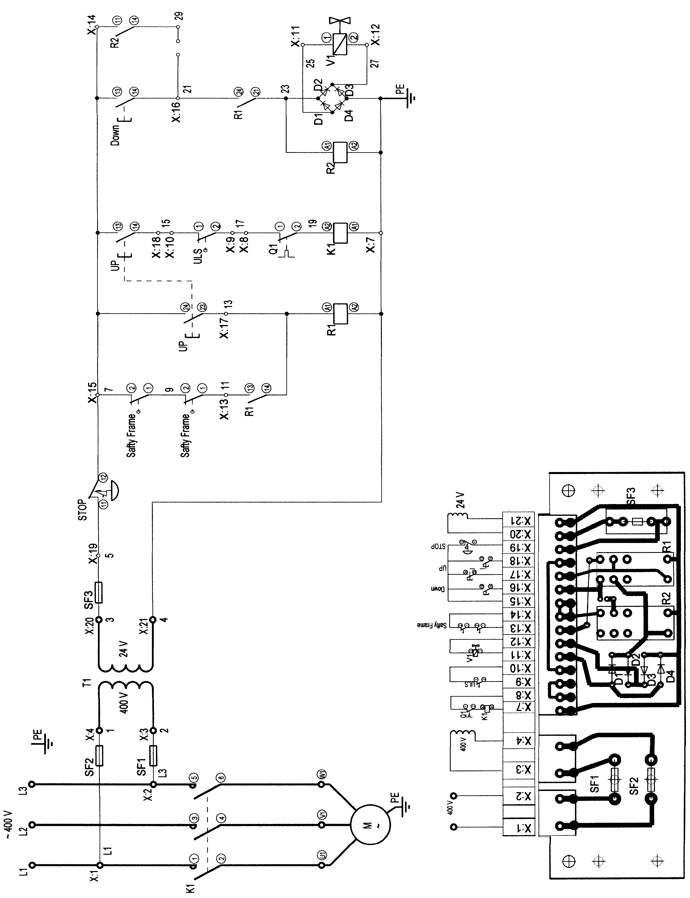

6.2 CONNECTION DIAGRAM

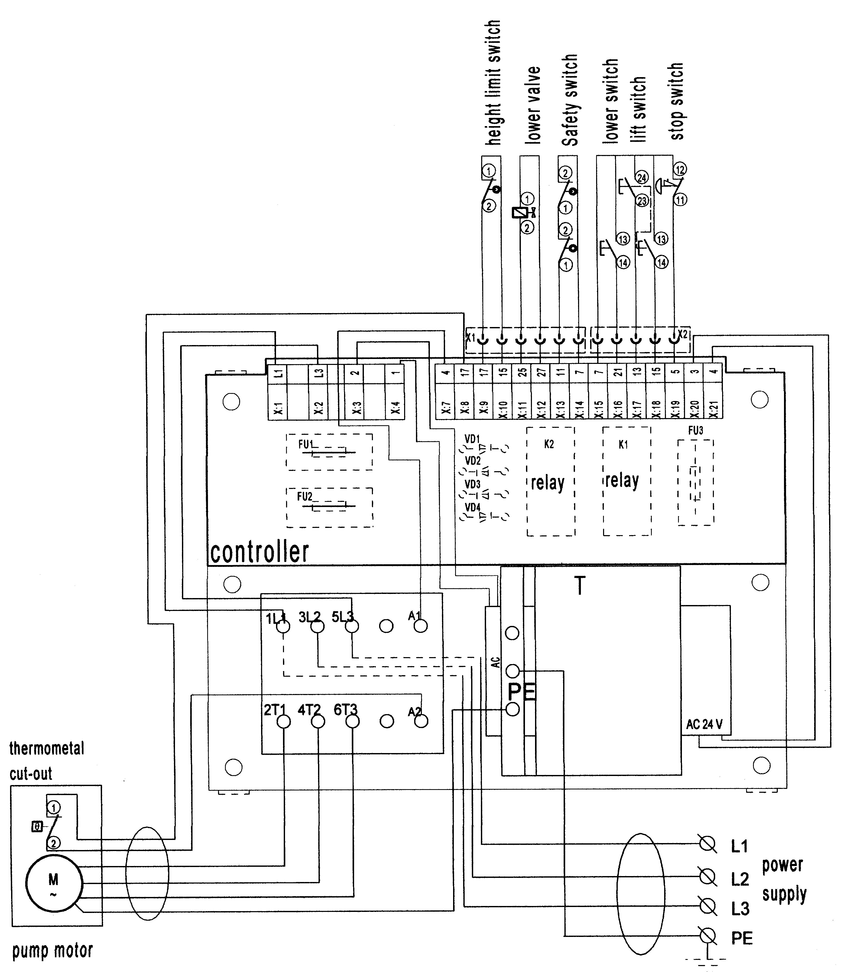

7. Hydraulic System

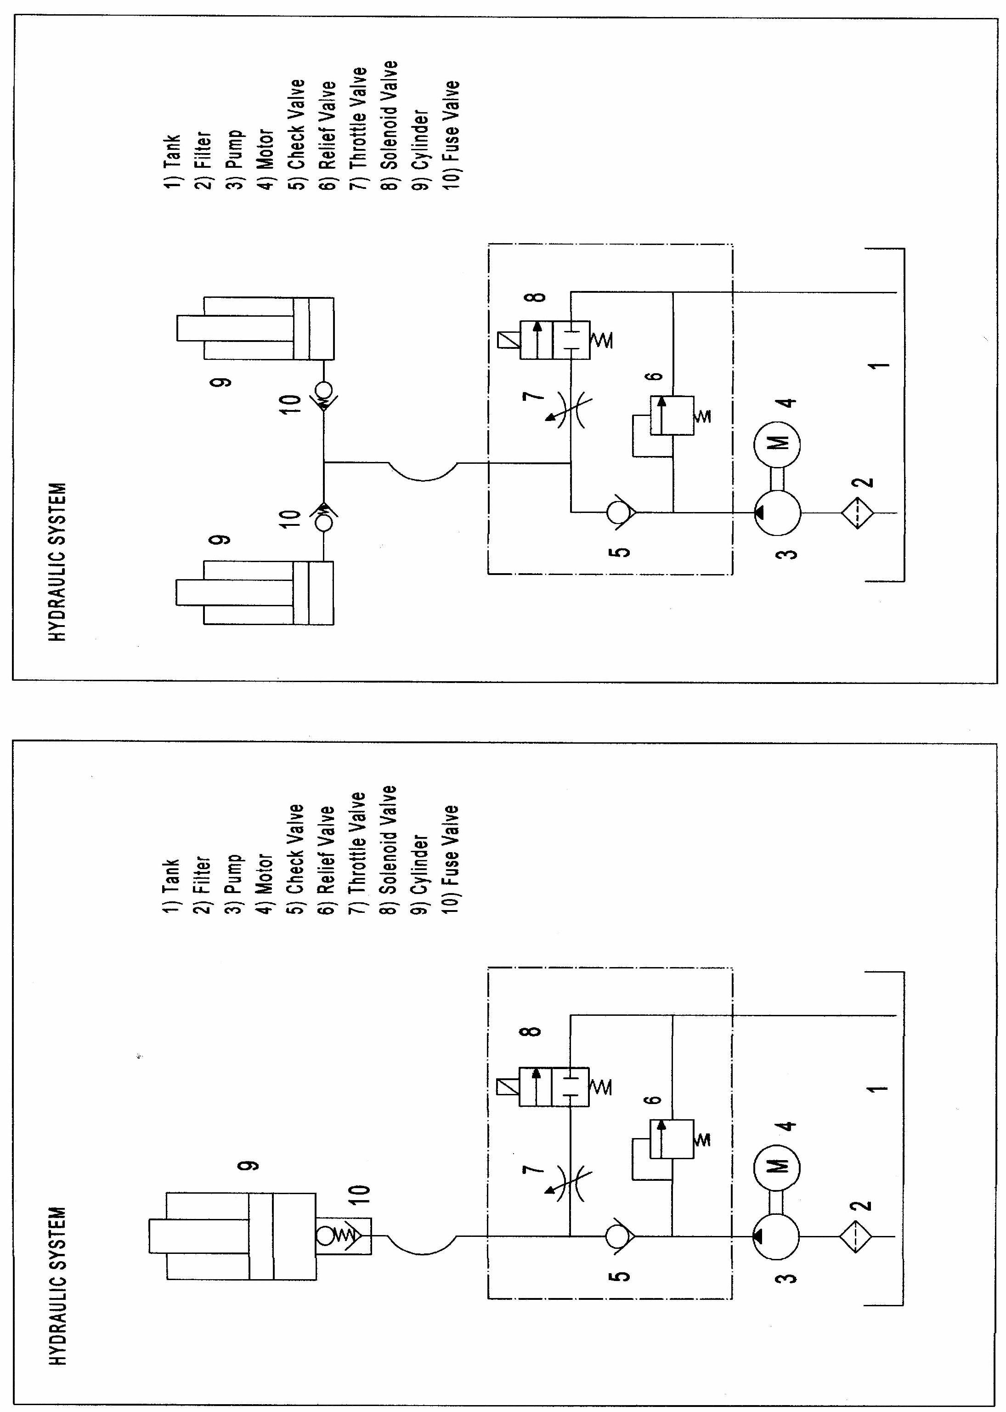

8. Exploded Figure and Parts List

8.1 HIW50 (1000LBS/500KG)
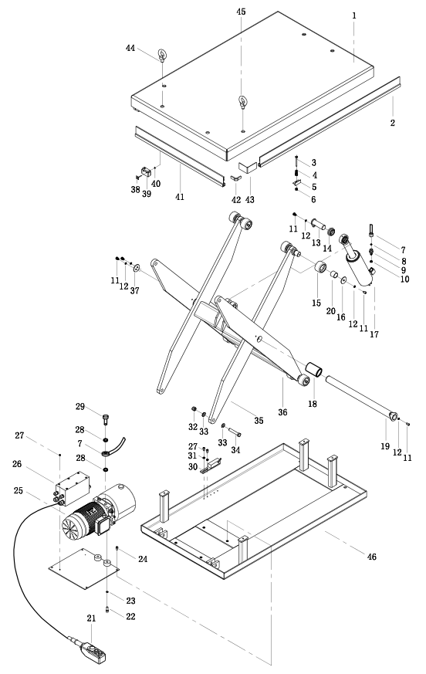
Figure 1: HIW50 (1000LBS/500KG)
NO | Description | QTY. | NO | Description | QTY.
1 | table | 1 | 24 | bolt | 4
2 | safety frame | 2 | 25 | hydraulic power pack | 1
3 | bolt | 4 | 26 | electric box | 1
4 | spring | 4 | 27 | screw | 4
5 | buffer-board | 4 | 28 | washer | 2
6 | nut | 4 | 29 | joint | 1
7 | high pressure hose | 1 | 30 | travel switch | 1
8 | O ring | 1 | 31 | washer | 4
9 | hose break vable | 1 | 32 | nut | 4
10 | seal ring | 1 | 33 | washer | 4
11 | bolt | 12 | 34 | bolt | 4
12 | spring washer | 12 | 35 | internal scissors | 1
13 | shaft | 1 | 36 | external scissors | 1
14 | bearing | 1 | 37 | washer | 1
15 | roller | 8 | 38 | fixed-board | 2
16 | washer | 8 | 39 | safety switch | 2
17 | cylinder | 1 | 40 | nut | 2
18 | bushing | 2 | 41 | safety frame II | 2
19 | shaft | 1 | 42 | fixed-board | 4
20 | bushing | 8 | 43 | connected-board | 4
21 | control switch | 1 | 44 | lifting bolt | 3
22 | bolt | 2 | 45 | bolt | 1
23 | sping washer | 2 | 46 | chassis | 1

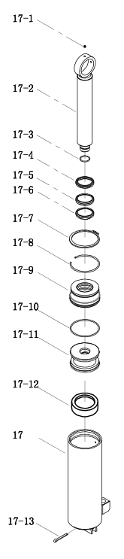
Figure 2:THE CYLINDER of HIW50 (1000LBS/500KG)

NO | Description | NO | Description
17 | cylinder | 17-7 | snap ring
17-1 | grease cup | 17-8 | steel ring
17-2 | piston rod | 17-9 | cylinder cover
17-3 | steel ring | 17-10 | O-ring
17-4 | dust ring | 17-11 | piston
17-5 | Y-ring | 17-12 | combination ring
17-6 | ring | 17-13 | split pin

8.2 HIW100 (2000LBS/1000KG)

Figure 3: HIW100 (2000LBS/1000KG)
NO | Description | QTY. | NO | Description | QTY.
1 | table | 1 | 24 | bolt | 4
2 | safety frame | 2 | 25 | hydraulic power pack | 1
3 | bolt | 4 | 26 | electric box | 1
4 | spring | 4 | 27 | screw | 4
5 | buffer-board | 4 | 28 | washer | 2
6 | nut | 4 | 29 | joint | 1
7 | high pressure hose | 1 | 30 | travel switch | 1
8 | O ring | 1 | 31 | washer | 4
9 | hose break vable | 1 | 32 | nut | 4
10 | seal ring | 1 | 33 | washer | 4
11 | bolt | 12 | 34 | bolt | 4
12 | spring washer | 12 | 35 | internal scissors | 1
13 | shaft | 1 | 36 | external scissors | 1
14 | bearing | 1 | 37 | washer | 1
15 | roller | 8 | 38 | fixed-board | 2
16 | washer | 8 | 39 | safety switch | 2
17 | cylinder | 1 | 40 | nut | 2
18 | bushing | 2 | 41 | safety frame II | 2
19 | shaft | 1 | 42 | fixed-board | 4
20 | bushing | 8 | 43 | connected-board | 4
21 | control switch | 1 | 44 | lifting bolt | 3
22 | bolt | 2 | 45 | bolt | 1
23 | sping washer | 2 | 46 | chassis | 1

Figure 4:THE CYLINDER of HIW100 (2000LBS/1000KG)

NO | Description | NO | Description
17 | cylinder | 17-7 | snap ring
17-1 | grease cup | 17-8 | steel ring
17-2 | piston rod | 17-9 | cylinder cover
17-3 | steel ring | 17-10 | O-ring
17-4 | dust ring | 17-11 | piston
17-5 | Y-ring | 17-12 | combination ring
17-6 | ring | 17-13 | split pin

8.3 HIW200 (4000LBS/2000KG)
Figure 5: HIW200 (4000LBS/2000KG)
NO | Description | QTY. | NO | Description | QTY.
1 | table | 1 | 24 | bolt | 4
2 | safety frame | 2 | 25 | hydraulic power pack | 1
3 | bolt | 4 | 26 | electric box | 1
4 | spring | 4 | 27 | screw | 4
5 | buffer-board | 4 | 28 | washer | 2
6 | nut | 4 | 29 | joint | 1
7 | high pressure hose | 1 | 30 | travel switch | 1
8 | O ring | 1 | 31 | washer | 4
9 | hose break vable | 1 | 32 | nut | 4
10 | seal ring | 1 | 33 | washer | 4
11 | bolt | 12 | 34 | bolt | 4
12 | spring washer | 12 | 35 | internal scissors | 1
13 | shaft | 1 | 36 | external scissors | 1
14 | bearing | 1 | 37 | washer | 1
15 | roller | 8 | 38 | fixed-board | 2
16 | washer | 8 | 39 | safety switch | 2
17 | cylinder | 2 | 40 | nut | 2
18 | bushing | 2 | 41 | safety frame II | 2
19 | shaft | 1 | 42 | fixed-board | 4
20 | bushing | 8 | 43 | connected-board | 4
21 | control switch | 1 | 44 | lifting bolt | 3
22 | bolt | 2 | 45 | bolt | 1
23 | sping washer | 2 | 46 | chassis | 1

Figure 6:THE CYLINDER of HIW200(4000LBS/2000KG)

NO | Description | NO | Description
17 | cylinder | 17-7 | snap ring
17-1 | grease cup | 17-8 | steel ring
17-2 | piston rod | 17-9 | cylinder cover
17-3 | steel ring | 17-10 | O-ring
17-4 | dust ring | 17-11 | piston
17-5 | Y-ring | 17-12 | combination ring
17-6 | ring | 17-13 | split pin

8.4 HIW300 (6000LBS/3000KG)
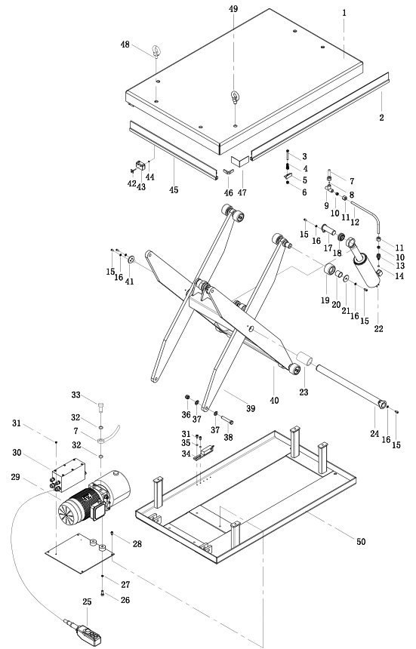
Figure 7:THE CYLINDER of HIW300(6000LBS/3000KG)
NO | Description | QTY. | NO | Description | QTY.
1 | table | 1 | 26 | bolt | 2
2 | safety frame | 2 | 27 | spring washer | 2
3 | bolt | 4 | 28 | bolt | 4
4 | spring | 4 | 29 | hydraulic power pack | 1
5 | buffer-board | 4 | 30 | electric box | 1
6 | nut | 4 | 31 | screw | 2
7 | high pressure hose | 1 | 32 | washer | 2
8 | O ring | 1 | 33 | joint | 1
9 | T joint | 1 | 34 | travel switch | 1
10 | sleeve | 2 | 35 | spring washer | 2
11 | nut | 2 | 36 | nut | 2
12 | steel tube | 2 | 37 | washer | 4
13 | hose break vable | 2 | 38 | bolt | 2
14 | seal ring | 2 | 39 | internal scissors | 1
15 | bolt | 11 | 40 | external scissors | 1
16 | spring washer | 11 | 41 | washer | 1
17 | shaft | 2 | 42 | fixed-board | 2
18 | bearing | 2 | 43 | safety switch | 2
19 | roller | 8 | 44 | nut | 2
20 | bushing | 5 | 45 | safety frame II | 2
21 | washer | 8 | 46 | fixed-board | 4
22 | cylinder | 2 | 47 | connected-board | 4
23 | bushing | 2 | 48 | lifting bolt | 3
24 | shaft | 1 | 49 | bolt | 1
25 | control switch | 1 | 50 | chassis | 1

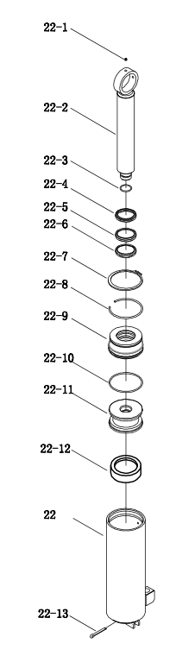
Figure 8:THE CYLINDER of HIW300(6000LBS/3000KG)

NO | Description | NO | Description
22 | cylinder | 22-7 | snap ring
22-1 | grease cup | 22-8 | steel ring
22-2 | piston rod | 22-9 | cylinder cover
22-3 | steel ring | 22-10 | O-ring
22-4 | dust ring | 22-11 | piston
22-5 | Y-ring | 22-12 | combination ring
22-6 | ring | 22-13 | split pin

