Instruction Manual

Drum Tongs

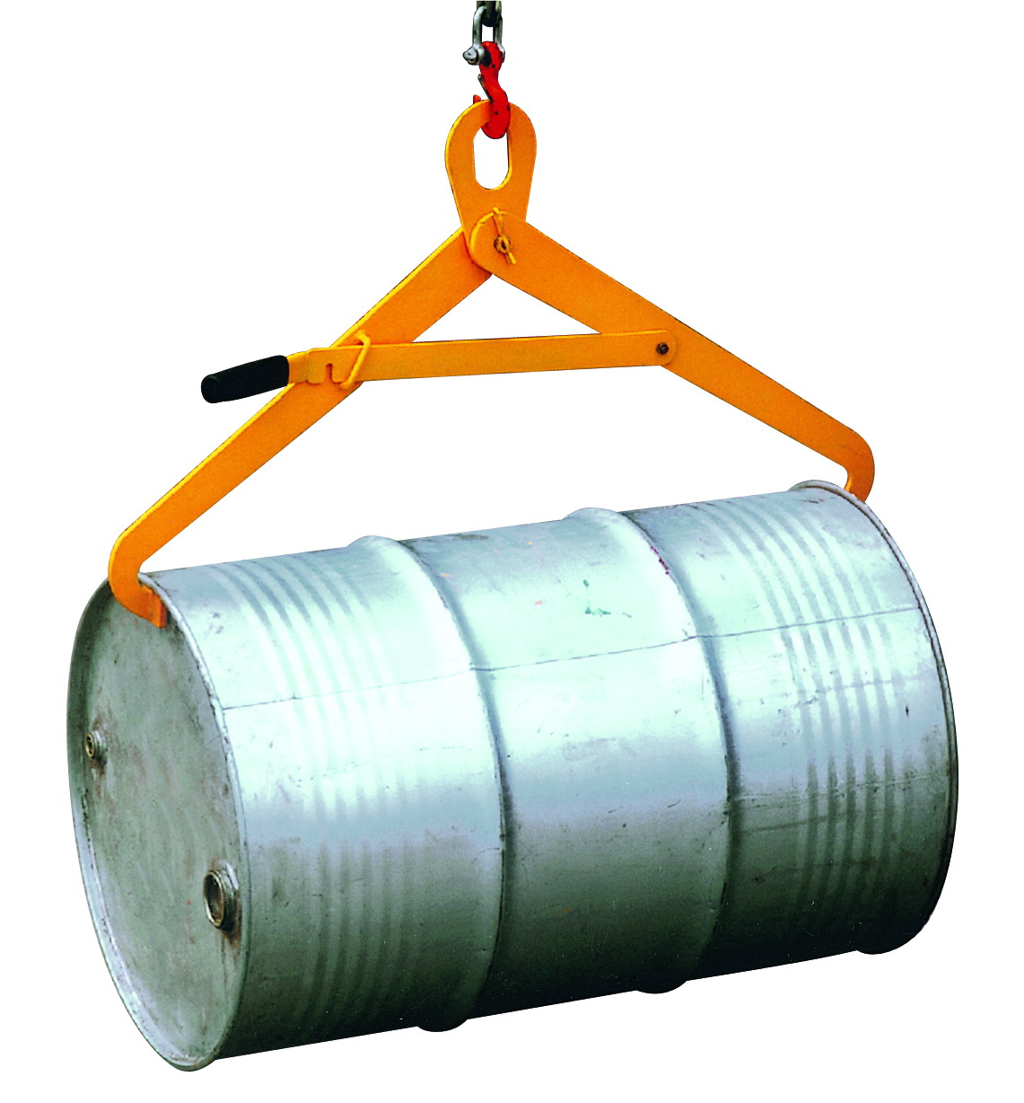

DN500

Note: The Owner/Operator must read carefully and understand
all the information presented here before operation.
0
THANK YOU FOR USING THIS DRUM TONGS. FOR YOUR SAFETY AND CORRECT OPERATION, PLEASE CAREFULLY READ THIS INSTRUCTION BEFORE USING IT.

NOTE: All of the information reported herein is based on data available at the moment of printing. The factory reserves the right to modify its own products at any moment without notice and incurring in any sanction. So it is suggested to always verify possible updates.

WARNING
    - Read and understand the entire owner’s manual before using the drum tongs.
    - These drum tongs are designed to lift drums in horizontal position only, as shown in the photo at left. The drum ends may be open or closed.
    - Do not load the drum tongs beyond their rated capacity of 1100 lbs.
    - Inspect the drum tongs before each use. If there is damage or distortion of any part, the drum tongs must be removed from service until they are repaired or replaced.
    - Make sure the drum is secured by the tongs before raising.
    - Do not allow anyone to stand beneath a raised drum.
    - Never leave a drum unattended in the raised position.
    - Do not use these drum tongs for other than their intended use.
    - Failure to comply with these warnings may result in personal injury and/or property damage.

OPERATION Of DRUM TONGS
- Place the ring of the drum tongs upon the hook of your hoist, chain block, etc.
- Lower the tongs over the drum, and make sure the tongs are secured under the rims of the drum.
- Carefully move the drum to desired location. When the drum has been lowered to the floor or pallet, the resulting slack will cause the tongs to lock in the open position and disengage from the drum.

SPECIFICATION
Capacity....................................................................................1100 lbs. Drum Size...............................................................55 gallon (210 liter) Net Weight...................................................................................18 lbs.

EXPLODED VIEW & PART LIST

No. | Description | Size | Qty | Remark
1 | Left jaw |  | 1
2 | Ring |  | 1
3 | Clevis pin |  | 1
4 | Split pin | Φ3.5㎜ | 1
5 | Washer | Φ20㎜ | 1
6 | Hex nut | M8 | 1
7 | Right jaw |  | 1
8 | Flat washer | Φ8㎜ | 1
9 | Hex cap screw | M8×25 | 1
10 | Locking handle |  | 1

