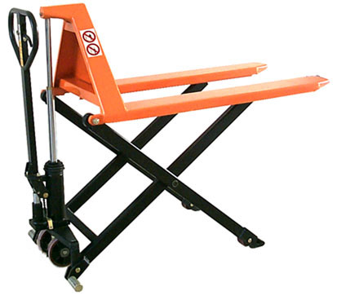

Owner’s
manual

Caution:
Before use,
Always read
Instructions
And procedures
Carefully for safe
operation

High Lift Pallet Truck
Hand operated

Operation Maintenance

Specifications
Article number | 1830043016 JL5210
Description | PL 1000 Scissor 2000 mm
Lift capacity (kg) | 1000
Min. fork height (mm) | 85
Max. fork height (mm) | 800
Load center (mm) | 1350
Min. total height (mm) | 527
Max. total height (mm) | 1247
Total width (mm) | 542
Total length (mm) | 2370
Fork width (mm) | 520
Fork length (mm) | 2000
Lift speed unladen (mm/s) | ≥24
Lift speed laden (mm/s) | ≥10
Lowering speed unladen (mm/s) | 50∽100
Lowering speed laden (mm/s) | 30∽100
Power of hydraulic pump (W) | no
Battery (Type, Ah and volt) | no
Charger (Type, volt and ampere) | no
Fork wheels | ∮75*50，PU
Drive wheel | ∮150*40，PU
Net weight, including battery (kg) | 180kgs
Color (Description and RAL code) | RAL1028
Amount of wood in packaging (kg) | 2pcs

Safety Instructions
- The truck shall be used in accordance with instructions handbook.
- Don’t put the hand & foot under the fork at any time.
- Don’t work on the slope surface.
- Quick lifting is prohibited for loads of more than 300 kgs. Any manipulation of the pressure relief valve is strictly prohibited. All assembling, adjusting and maintenance shall only be done by industrial mechanics trained people. These people must be familiar with all safety regulations of European and national where the item is in use relating to the operation and maintenance of pedestrian controlled industrial trucks.
- Load should be put on the fork center. Side-load is strictly prohibited.
- The truck shall not be used to transport persons.
- It is recommended to the driver to wear security shoes.
- No modifications shall be carried out which adversely affect the compliance of the truck with prEN 1757-4.

Installation & Adjustment
- Screw(part No.158)
● To prevent oil-leaking from oil tank during transportation, Air Screw (part No.158) is replaced with Oil-sealing Screw in the factory. But it has to be replaced back when you put this truck in use.
● How to change: Screw out Oil-sealing Screw, then screw in Air Screw With which the Pump housing(No.160) is hung, thus keep oil tank always connecting with atmosphere.
- Handle
During transportation, the handle is disassembled from the truck and packed separately. It has to be assembled back and adjusted properly and carefully before use.

A Handle installation:
● Take 3 pieces of M10 Nut (No.185) & Spring washer from spare parts bag. Select handle to match the truck with the same fitting numbers.
● Assemble the handle on the Handle Base (No.181) with 3 pieces of M10 Nut & Spring Washer tightly.
● Put the chain’s Eye Bolt (No.110) in the slot at the front end of Pendulum Arm (No.112).
B Handle adjustment
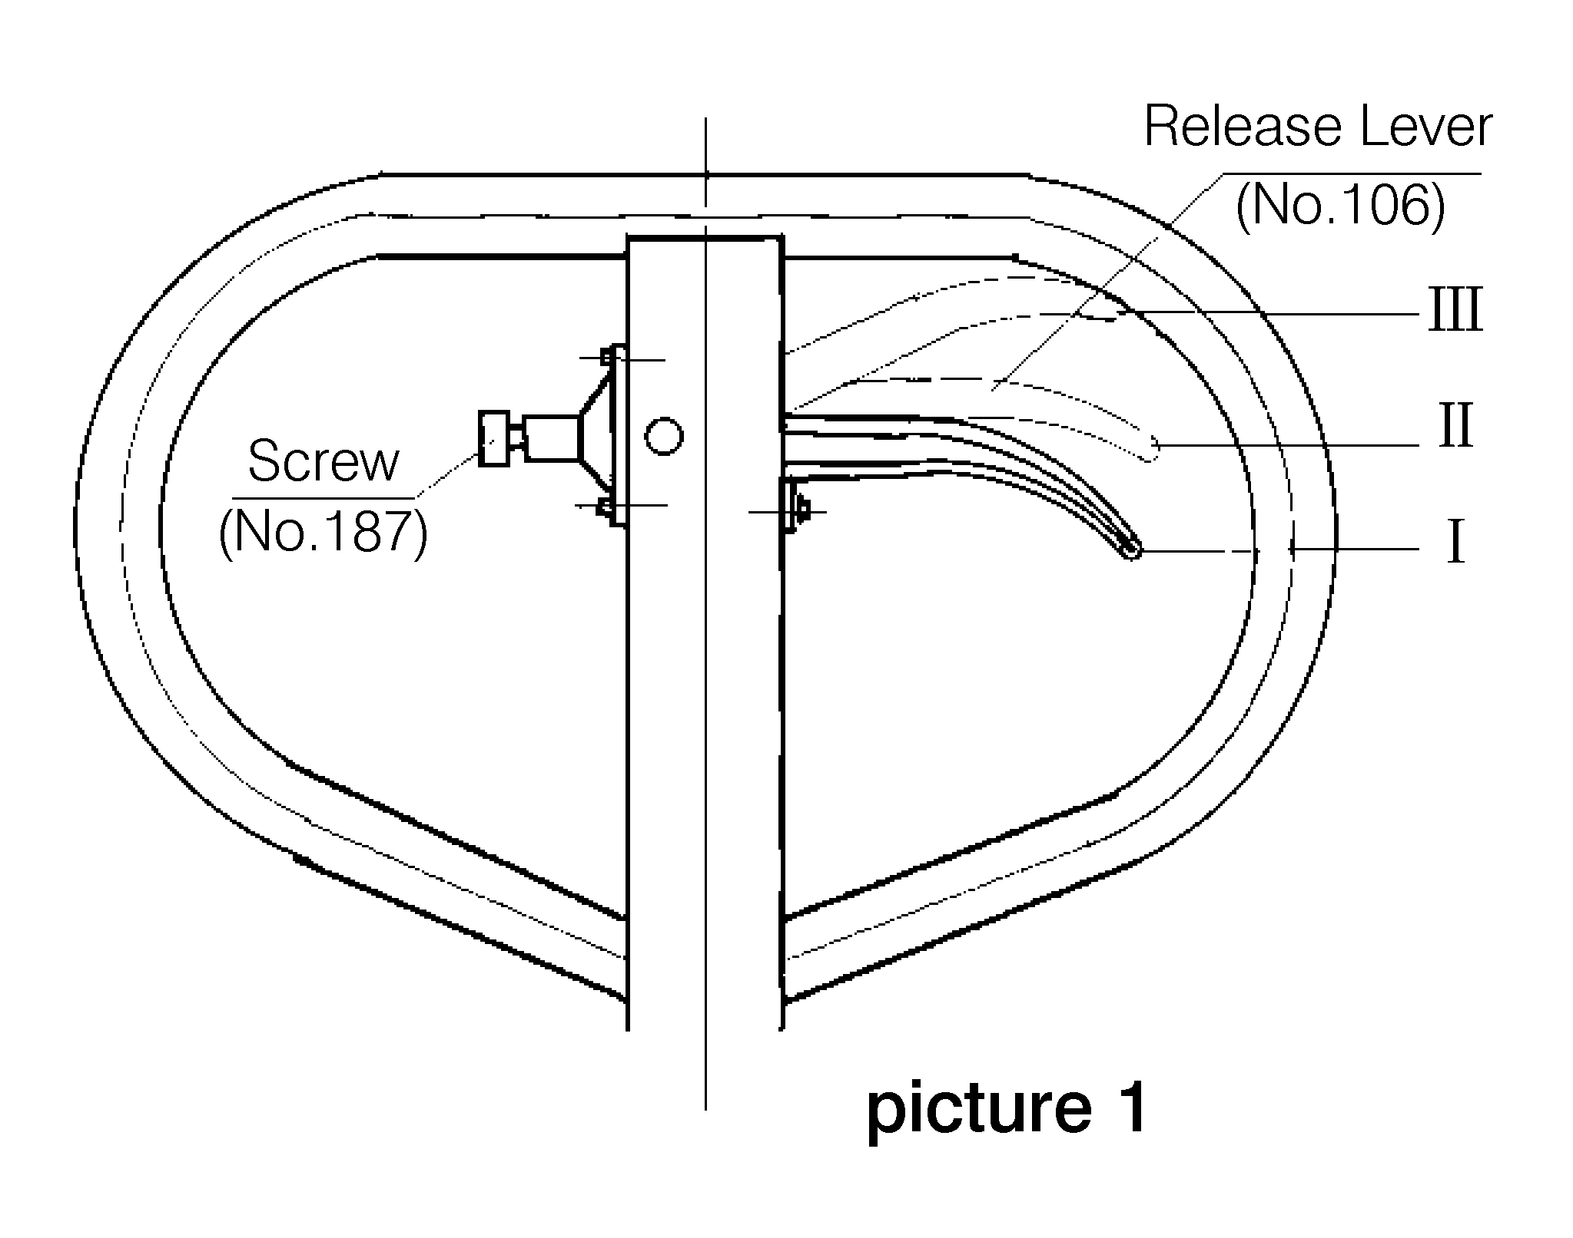
● There are 3 different positions with different functions for the Release Lever
(part No.106).
See picture 1

Position I: Quick lifting for fork.

Position II: Slow lifting for fork.

Position III: Descending for fork.

● Test different functions by putting the Release
Lever in 3 different positions respectively.
If it does not function properly, then adjusting
Lock Nut (No.113) by followingprocess. See picture 2

Problems | Turning direction of Lock Nut
Fork not lifted up | – (counter-clockwise)
Fork not lowering down | + (clockwise)
Slow lifting no function | + (clockwise)
Quick lifting no function | – (counter-clockwise)

● Function of Adjusting Screw (No.187) for Release Lever (see picture 1)

To fix release lever (No.106) into its 3 positions properly by adjusting the screw, you can adjust the operating force of the release lever.
To prevent accidental touch of the Release Lever which could cause sudden sliding down of the fork. You can tighten the Screw (No.187) in the position I or II of the Release Lever (No.106).
See picture 1

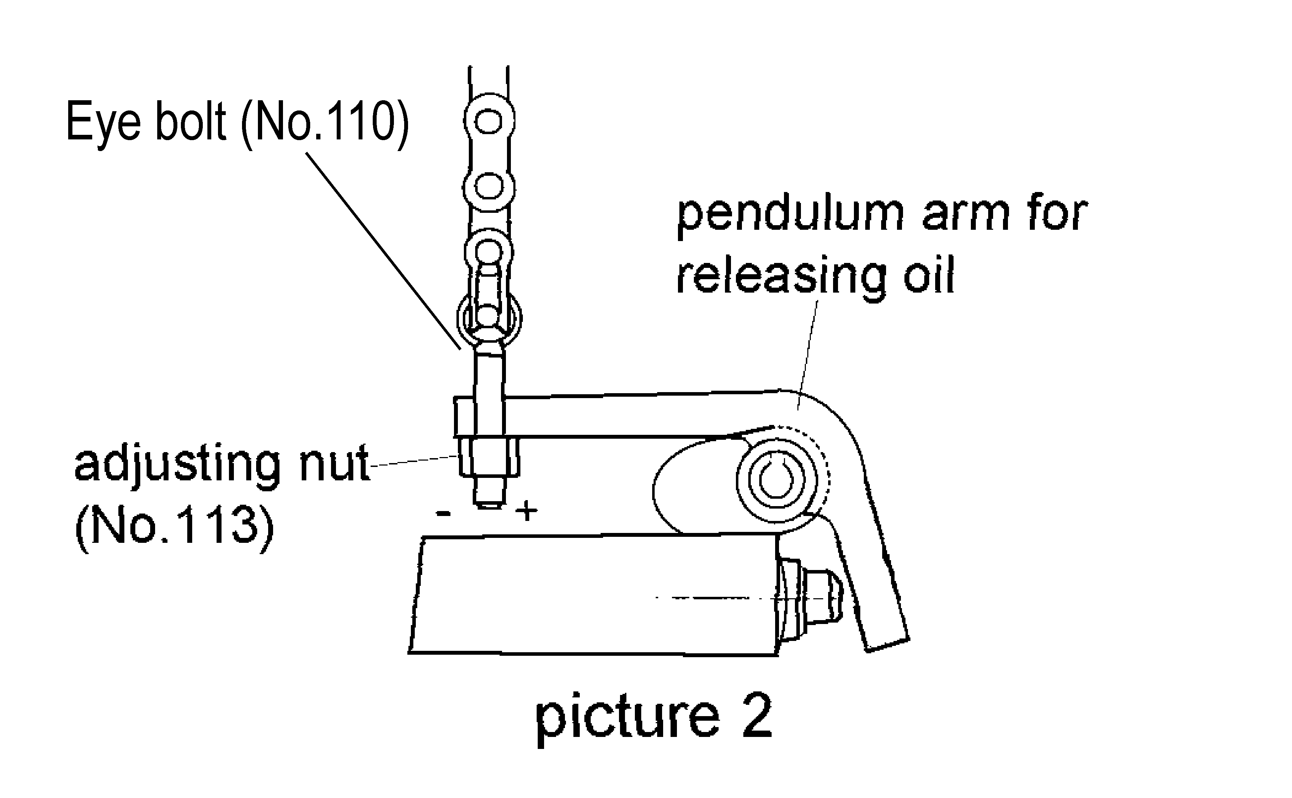

● How to release the air from the pump.

See picture 3

When pushing the handle down, the fork can’t be lifted instantly. Please
loosen the Screw (No.130) on the pump while pushing the handle
down slowly to release the air from the pump. Then tighten the screw.

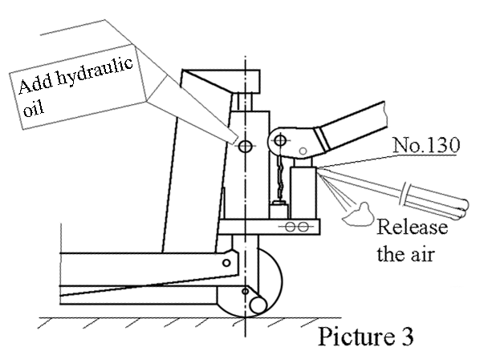

● When to add oil

See Picture 3

If the fork can’t be pumped up to its rated highest position, you may have to add hydraulic oil into the oil tank. The hydraulic fluid to be used must have a quality of ISO VG22 or equivalence. Mixing of different fluids is prohibited!

TROUBLE SHOOTING GUIDE
Items | Symptom | Possible cause | Aliments
1 | Fork can not be pumped up | 1． Low oil level in oil tank.  2． Exist air in the hydraulic system.  3. Adjusting nut is not adjusted properly. | 1 .Add proper hydraulic oil.  2. Fast operating the handle for several times. Bleed the system.  3. Adjust adjusting nut.  (see picture 2)
2 | Fork can’t be released down | 1． Fork blocked.  2. Adjusting nut not adjusted properly. | 1. Check and remove the block.  2. Adjust adjusting nut properly.  (see picture 2)
3 | Fork can’t be pumped up to rated highest position. | Oil is not enough. | Add hydraulic oil.  (see picture 3)
4 | Fork lifting speed has no difference between position I and position II of release lever. | Adjusting nut is not adjusted properly. | Adjust adjusting nut.  (see picture 2)

Parts List

No. | Description | Qt’y | No. | Description | Qt’y
1 | Fork | 1 | 18 | Washer | 2
2 | Screw | 1 | 19 | Nut | 2
3 | Nut | 1 | 20 | Washer | 8
4 | Power Unit | 1 | 21 | Ball Bearing | 8
5 | Hold Yoke | 1 | 22 | Front Wheel | 2
6 | Wheel Yoke | 1 | 23 | Wheel Axle | 2
7 | Centrifugal Axle | 2 | 24 | Roller | 4
8 | Spacer | 2 | 25 | Bush | 2
9 | Steering Wheel | 2 | 26 | Washer | 4
10 | Snap Ring | 8 | 27 | Spring Washer | 2
11 | Pin | 2 | 28 | Nut | 2
12 | Snap Ring | 12 | 31 | Screw | 1
13 | Bush | 2 | 32 | Nut | 1
14 | Leg | 2 | 30 | Steering Wheel Assembly  (incls.6,9,10,21、31、32) | 1
15 | Leg | 1 | 30 | Steering Wheel Assembly  (incls.6,9,10,21、31、32) | 1
16 | Bush | 2
17 | Pin | 2

Parts list
Part No. | DESCRIPTION | QTY | Part No. | DESCRIPTION | QTY
71 | Washer | 1 | 72 | Spring | 1
73 | Bush | 2 | 74 | Washer | 1
75 | Gasket | 1 | 101 | Locknut | 1
102 | Handle | 1 | 103 | Screw | 1
104 | Pin | 1 | 105 | Roller | 1
106 | Release Lever | 1 | 107 | Release Rod | 1
108 | Chain Connector | 3 | 109 | Chain | 1
110 | Eye Bolt | 1 | ※111 | Washer | 1
112 | Pendulum Arm | 1 | 113 | Pendulum Arm Nut | 1
114 | Positioner | 1 | 115 | Screw | 5
116 | Washer | 2 | 117 | Pin | 1
118 | Valve Insert | 1 | 119 | Seat | 1
120 | Screw | 2 | 121 | Gasket | 2
122 | Spring | 2 | 123 | Release Valve | 2
124 | Ball | 2 | 125 | Valve Insert | 1
126 | O-Ring | 8 | 127 | Spring | 1
※ 128 | O-Ring | 1 | 129 | Release Indicator | 1
※ 130 | Screw | 1 | 131 | Pump Piston | 1
132 | Guide Ring | 1 | 133 | Y-Ring | 1
134 | Washer | 1 | 135 | Snap Ring | 1
136 | Scraper Ring | 2 | 137 | O-Ring | 2
138 | Y-Ring | 2 | 139 | Pump Cylinder | 1
140 | O-Ring | 1 | 141 | Spring | 1
142 | Hi-pressure Piston | 1 | 143 | O-Ring | 1
144 | Ball | 1 | 145 | Spring | 1
146 | Adjusting Screw | 1 | 147 | Sealing Screw | 1
148 | Screw | 1 | 149 | Snap Ring | 2
150 | O-Ring | 2 | 153 | O-Ring | 1
155 | O-Ring | 1 | 157 | Screw | 1
158 | Air Screw | 1 | 159 | Cylinder | 1
160 | Pump Housing | 1 | 161 | Thrust Bearing | 1

Part No. | DESCRIPTION | QTY | Part No. | DESCRIPTION | QTY
162 | Ball | 1 | 163 | Snap Ring | 1
164 | Washer | 1 | 170 | Bush | 2
171 | Piston | 1 | 172 | Screw | 1
173 | Axle | 1 | 174 | Gasket | 1
175 | Lock Screw | 1 | 176 | Rubber Sleeve | 1
177 | Washer | 1 | 178 | Washer | 5
180 | Adjusting Screw | 1 | 181 | Handle Base | 1
182 | Adjusting Washer | 1 | 183 | Rubber Sleeve | 1
184 | Spring Guide | 1 | 185 | Screw | 3
186 | Spring Washer | 3 | 187 | lock Screw For Release Lever | 1
188 | Spring Socket | 1 | 189 | Spacer | 2
190 | Copper Piston | 1 | 191 | Snap Ring | 1
192 | Snap Ring | 2 | 193 | Spring | 1
194 | Pin | 1 | 195 | Ball | 1
301 | Bush | 1 | 302 | Back-Up ring | 1
303 | Y-Ring | 1 | 304 | Bush | 1
305 | Snap Ring | 1 | 306 | Piston Rod | 1
307 | Cylinder Head | 1 | 308 | Lifting Ram | 1
300 | Pump unit  (incls.71,72,73,74,75,104,105,111,112,117,118,119,120,121,122,123,  124,125,126,127,128,129,130,131,132,133,134,135,136,137,138,  139,  140,141,142,143,144,145,146,147,148,149,150,153,155,157,158,159,  160,163,164,170,171,172,173,174,175,176,177,180,181,182,183,  184,  185,186,190,191,192,301,302,303,304,305,306,307,308) |  |  |  | 1
50 | Handle assembly  (incls.101,102,103,106,107,108,109,110,113,114,115,116,178,187,188,189,193,194,195) |  |  |  | 1
Remark： Parts with “※” mark are supplied together with the High Lifter
and packed in the poly bags.

* VERSION TWO

