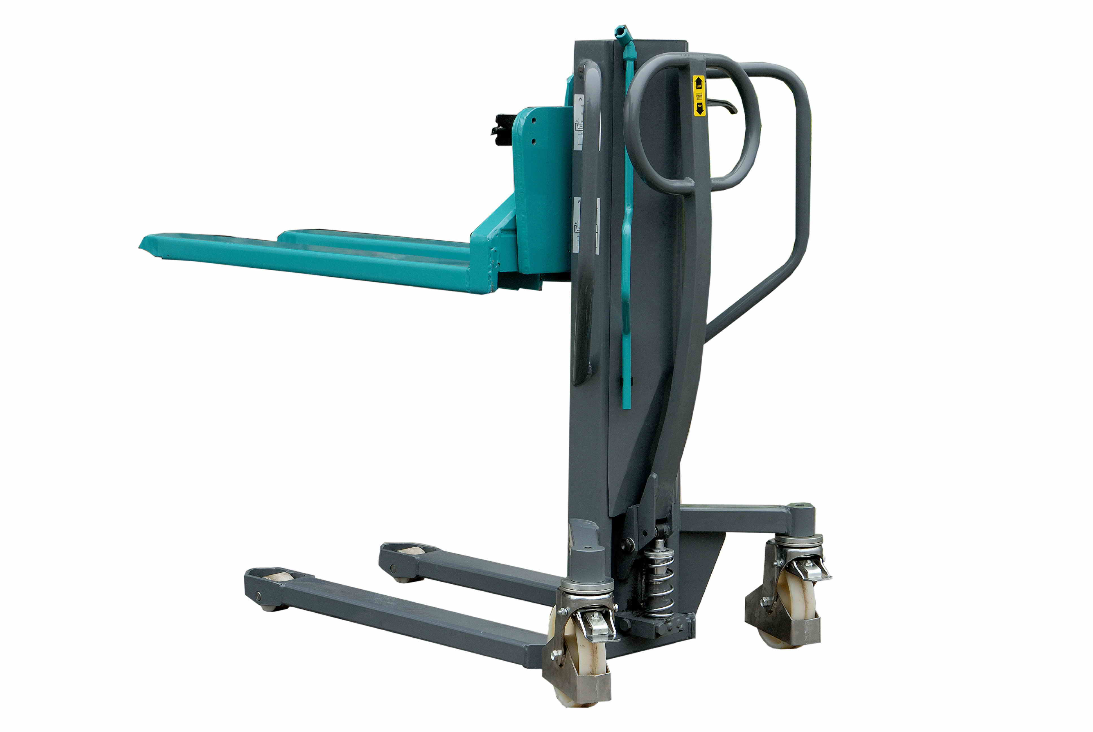Operation
and

maintenance
instruction

Spare
parts
list

High Lift Pallet Truck
HS-T0809

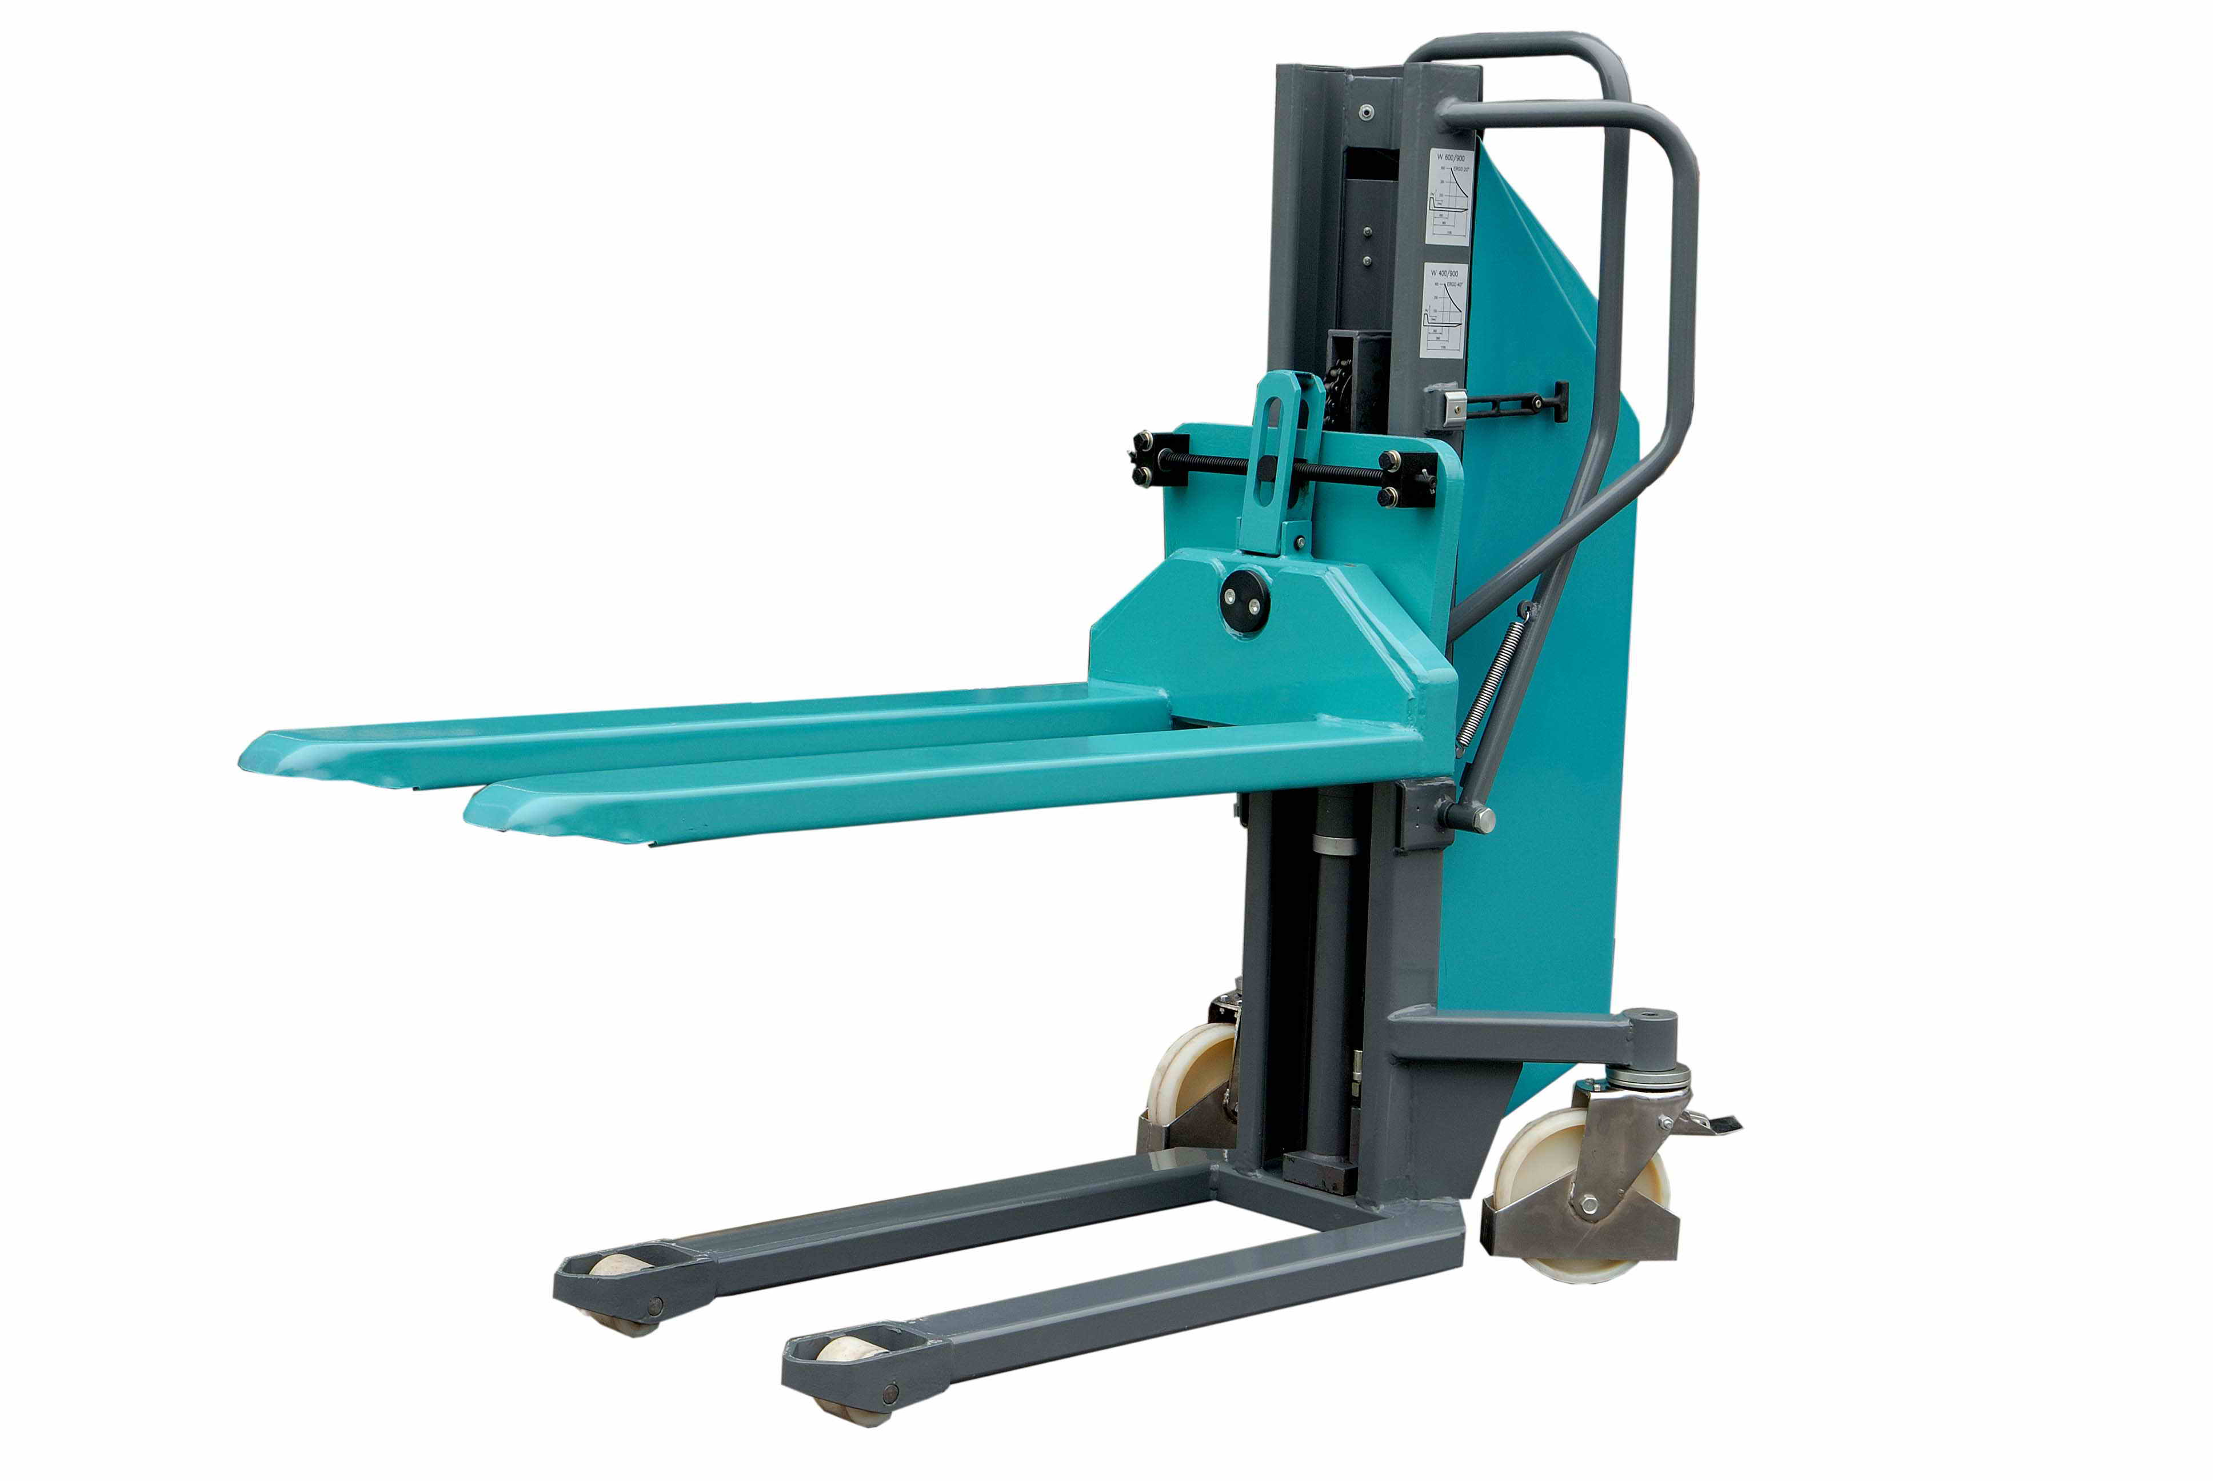
EHS-T0809

HS-T0809

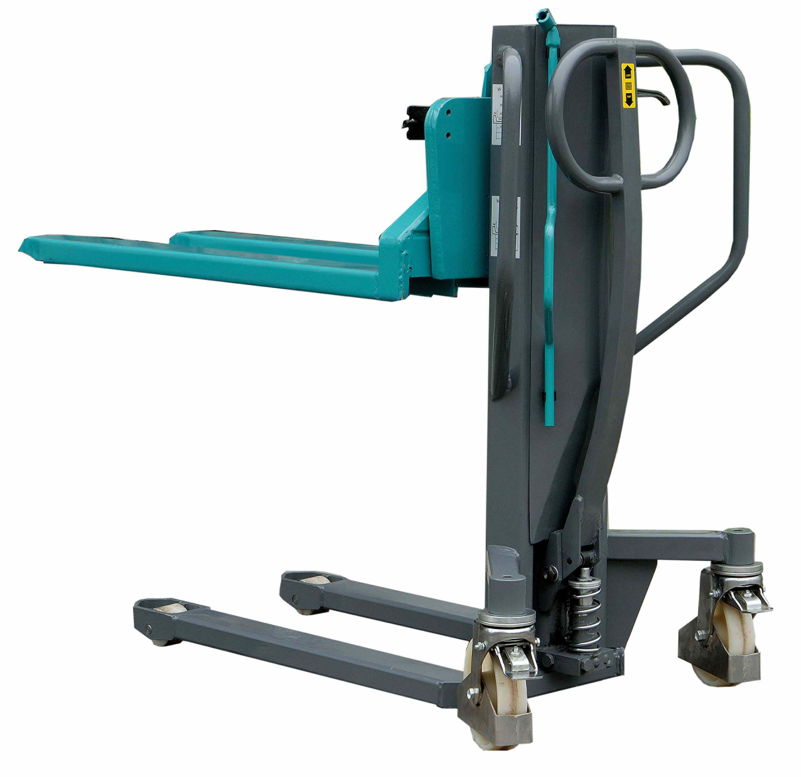
Frame

Lever
Tilting Forks

Handle

Crank

Parking brake

Operation and mai ntenance instruction
High Lift Pallet Truck HS-T0809

Manual high lift truck (later “truck” only) is designed for transport and material handling, loaded on transporting platforms or pallets, on flat and solid surfaces. It enables to offtake and to base pallets with material to the maximum lifting height of the truck and to tilt a load placed in a fence pallet with max. height 400 mm, i.e. with the position of the center of gravity 200 mm over forks by + 20°. It decreases physical strain of person manipulating with material.

 | HS-T0809
Loading capacity  Length  Width  Height  Length of the forks  Width of the fork  Min. height of the forks above the floor  Forks width  Truck weight  Lifting height  Bearing surface of the forks  Tilting angle of the forks  Lift with load (per 1 manual stroke)  Lift without load (per 1 manual stroke) | 800  1630  730  1230  1140  150  87  540  220  900  1140x540  ±20  ≥18  ≥60 | kg  mm  mm  mm  mm  mm  mm  mm  kg  mm  mm  °  mm  mm
Technical data

Operation instruction

The truck is supplied by the producer with its hydraulic block filled with hydraulic oil conforming to the standard ON 65 6890. It is recommended, at everyday usage, to check oil level once a month. The oil level is correct when its level is directly below the filling hole (closed with a plug) with the forks lowered into the lowest position. When refilling oil, it must be filtered through a 25 μm filter (alternative refills are SHELL TELLUST T 15, MOBIL DTE 11 M, CASTROL HYSPIN AWS 15).

Banishing the air in the hydraulic oil

When the truck is stored for a longer period or when a non-expert repair has been performed, the air can get into hydraulics and this will result in an incorect truck function. The air in hydraulics is indicated by the partial free movement of the handle while pumping, or uneven run of the forks occurs when lifting. This problem can be removed first of all by checking oil level. The control lever must be switched into its transport position (position “O”) and by pumping while in this position, air will be removed from the pump piston area. Then, switch the control lever into the lifting position (position “I”), pump the forks into their maximum height above the floor and make several more strokes. Now, the hydraulic block is correctly aired and you can lower the forks to their lowest position above the floor.
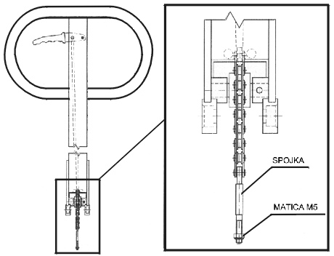

Adjusting the valve of the hydraulic block

- If the control lever is in lower position and no lifting of the forks occurs while pumping, the M5 nut located on the clutch must be loosened.
Clutch

- If the control lever is pressed in its upper position and no lowering of the forks occurs, the M5 nut located on the clutch must be tightened.
Nut M5

Operation manual

A worker older than 18 years of age, who is mentally and physically suitable and knows all safety regulations regarding material handling using low lift scissors trucks and their operation, may operate the truck. Truck operating activities are provided through the handle and on it positioned control lever, which is connected to hydraulic block. While manipulating (lifting, starting) with load that is heavier than 600 kg it is necessary that two people are operating the truck.
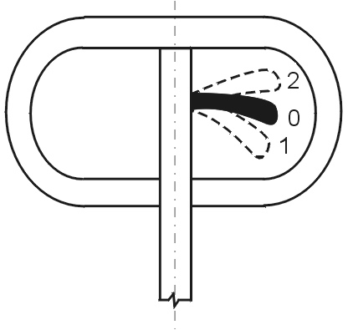
Lifting
pic. 1

The control lever must be in its lower position (position “I”, see the picture). Moving the handle up and down, hydraulic unit generates a power needed for lifting of a load.

Transporting the load (transport position)

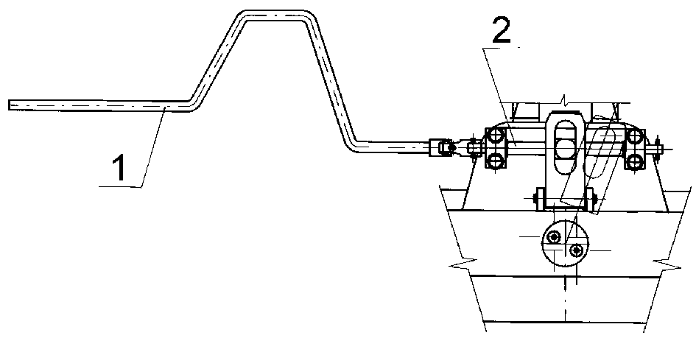
The control lever must be in its middle position (position “O”). While in this position, the load height is constant. The lever is in this position fixated. The forks are in their lower position cca 200 mm over the ground.

Lowering

Press the control lever to its upper position (position “2”). When in this position, the safety valve in the hydraulic unit opens and a truck frame sinks to its lowest position. The speed of the lowering depends on how much you press the control lever.

Tilting
pic. 2
Tilting of the forks by + 20° is provided mechanicaly by using a crank (see picture 2).
1 - Crank 2 - Trapezium screw

Loading diagram HS-T0809

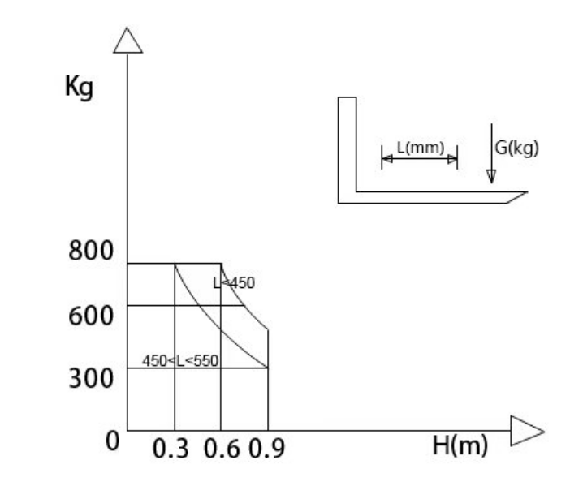

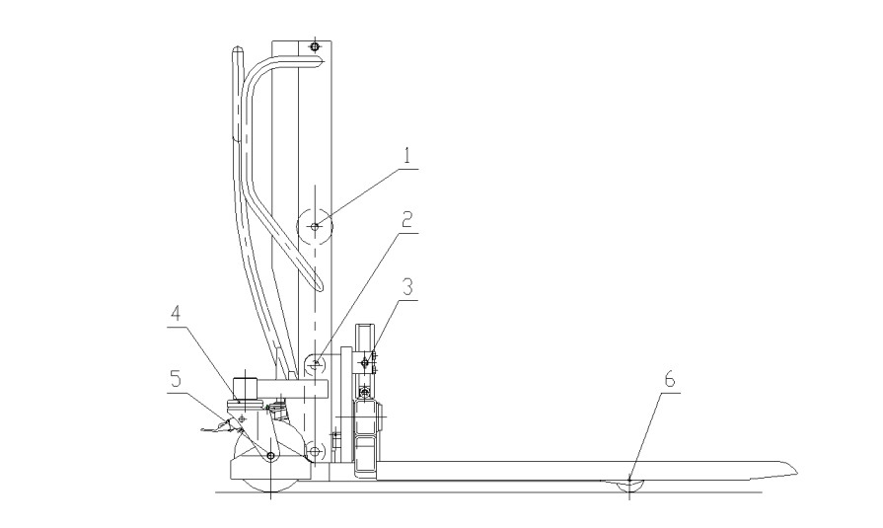
Lubricating plan

Pos.  No. | Place of lubrication | No. of places  HS-T0809 | Lubricant  type | Lubricant  quantity | Interval
1  2  3  4  5  6 | Chain wheel bearing  Forks bearing  Helix  Front wheel bearing  Front wheel bearing  Rear wheel bearing | 1  4  2  2  4  4 | T – K3  T – V2  T – V2  T – V2  T – V2  T – V2 | 0,01 kg  0,005 kg  0,005 kg  0,005 kg  0,005 kg  0,005 kg | Twice a year  Once a year  Once a year  Once a year  Once a year  Once a year
Safety regulations

When handling loads, operational procedures, which protect operators from accidents and injuries must be used. These are mainly caused by incorrectly secured loads, by exceeding the max. load capacity, or by sliding of the truck on poor transport surfaces. Doorsills and similar obstructions must be leveled by means of ramps as well as bridges between neighboring floors.

It is forbidden:

- to use the truck for handling on inclined surfaces
- to perform any repairs and maintenance on a truck carrying a load
- to handle loads with a center of gravity higher than 500 mm
- to transport the loads while lifted higher than it is specified 200 mm over the ground except
technological essential transport

Note:
- technological essential transport is offtaking and placing of the load in the place of stacking.

It is necessary:
- to keep the loading diagram while manipulating with load, which is sticked on each stacker.

Product disposal

The user of product is after the end of technical life obligatory:

- to drain the hydraulic system and to hand an oil over for recycling
- to hand over all metal parts for recycling
3. to put all plastic parts into communal waste system

Chain

HS-T0809

Chain 12 A-1 | L=857 (46 links) | 1 pcs

EHS-T0809

Chain 12 A-1 | L=857 (46 links) | 1 pcs

Piece list – hydraulic block
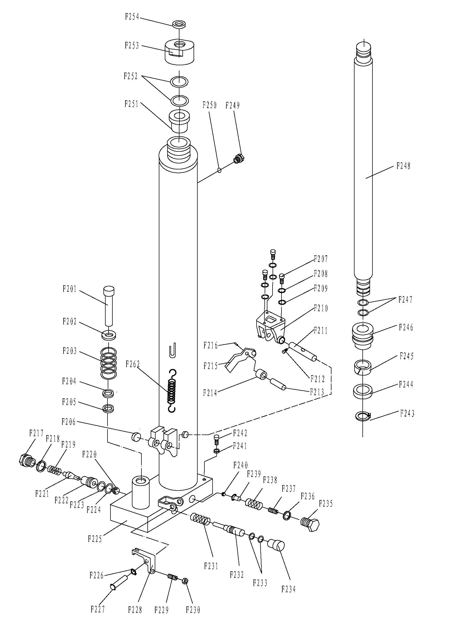

No. | Description | Qty. | No. | Description | Qty.
F201 | Pump Piston Rod | 1 | F229 | Screw | 1
F202 | Spring Washer | 1 | F230 | Nut | 1
F203 | Spring | 1 | F231 | Spring | 1
F204 | Dust Ring | 1 | F232 | Strike Pin | 1
F205 | Seal | 1 | F233 | O-Ring | 2
F206 | Bushing | 2 | F234 | Dust Catcher | 1
F207 | Screw | 3 | F235 | Cover with Screw | 1
F208 | Washer | 3 | F236 | Seal Washer | 1
F209 | Spring Washer | 3 | F237 | Adjusting Bolt | 1
F210 | Bracket | 1 | F238 | Spring | 1
F211 | Shaft for Roller | 1 | F239 | Spring Seat | 1
F212 | Screw | 1 | F240 | Steel Ball | 1
F213 | Shaft | 1 | F241 | Seal Washer | 1
F214 | Pressure Roller | 1 | F242 | Screw | 1
F215 | Lever of Pedal | 1 | F243 | Locking Ring | 1
F216 | Elastic Pin | 1 | F244 | Y-Ring | 1
F217 | Screw | 1 | F245 | Support Ring | 1
F218 | Seal Washer | 1 | F246 | Piston | 1
F219 | Spring | 1 | F247 | O-Ring | 2
F220 | Steel Ball | 1 | F248 | Lifting Piston Rod | 1
F221 | Valve Spindle of Pump | 1 | F249 | Screw | 1
F222 | Seat of pump Valve | 1 | F250 | Screw | 1
F223 | O-Ring | 1 | F251 | Conduit | 1
F224 | Washer | 1 | F252 | O-Ring | 2
F225 | Body of Pump | 1 | F253 | Cover with Screw | 1
F226 | Locking Ring | 1 | F254 | Dust Ring | 1
F227 | Elastic Pin | 1 | F262 | Spring | 2
F228 | Lever Plate | 1

Tilting forks

Tilting forks | Note
Tilting forks | Pcs | 2  2  2  4  4  4  1  2  2  1  1  1  1  1  2  1  4  1  1  4  4  4  8  4
Tilting forks | Description | Washer  Bearing  Trapezium screw holder  Plane washer 12  Spring washer 12  Screw M12x80  Fork arm pin  Snap ring 9  Cotter 5x30  Trapezium screw M20x4  Fork arm – welded  Trapezium screw stone  Washer  Push cover  Bolt  Tilting forks – welded  Bolt M5x8  Tie plate  Fork carrier – welded  Roller  Bearing  Snap ring 25  Washer 10  Pole
Tilting forks | Pos. | HS201T  HS202T  HS203T  HS204T  HS205T  HS206T  HS207T  HS208T  HS209T  HS2010T  HS2011T  HS2012T  HS2013T  HS2014T  HS2015T  HS2016T  HS2017T  HS2018T  HS2019T  HS2020T  HS2021T  HS2022T  HS2023T  HS2024T
Tilting forks | No. | 1  2  3  4  5  6  7  8  9  10  11  12  13  14  15  16  17  18  19  20  21  22  23  24

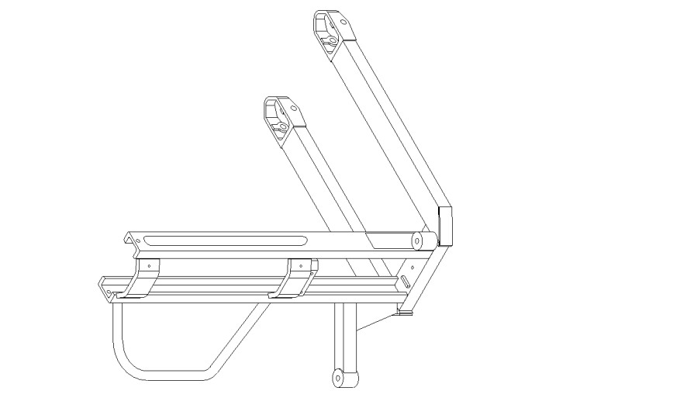

Frame – welded HS-T0809

Frame – welded HS-T0809 | This frame is welded by using more parts, which are comprised into one indemountable unit.

EHS-T0809

Description and illustration
EHS-T0809

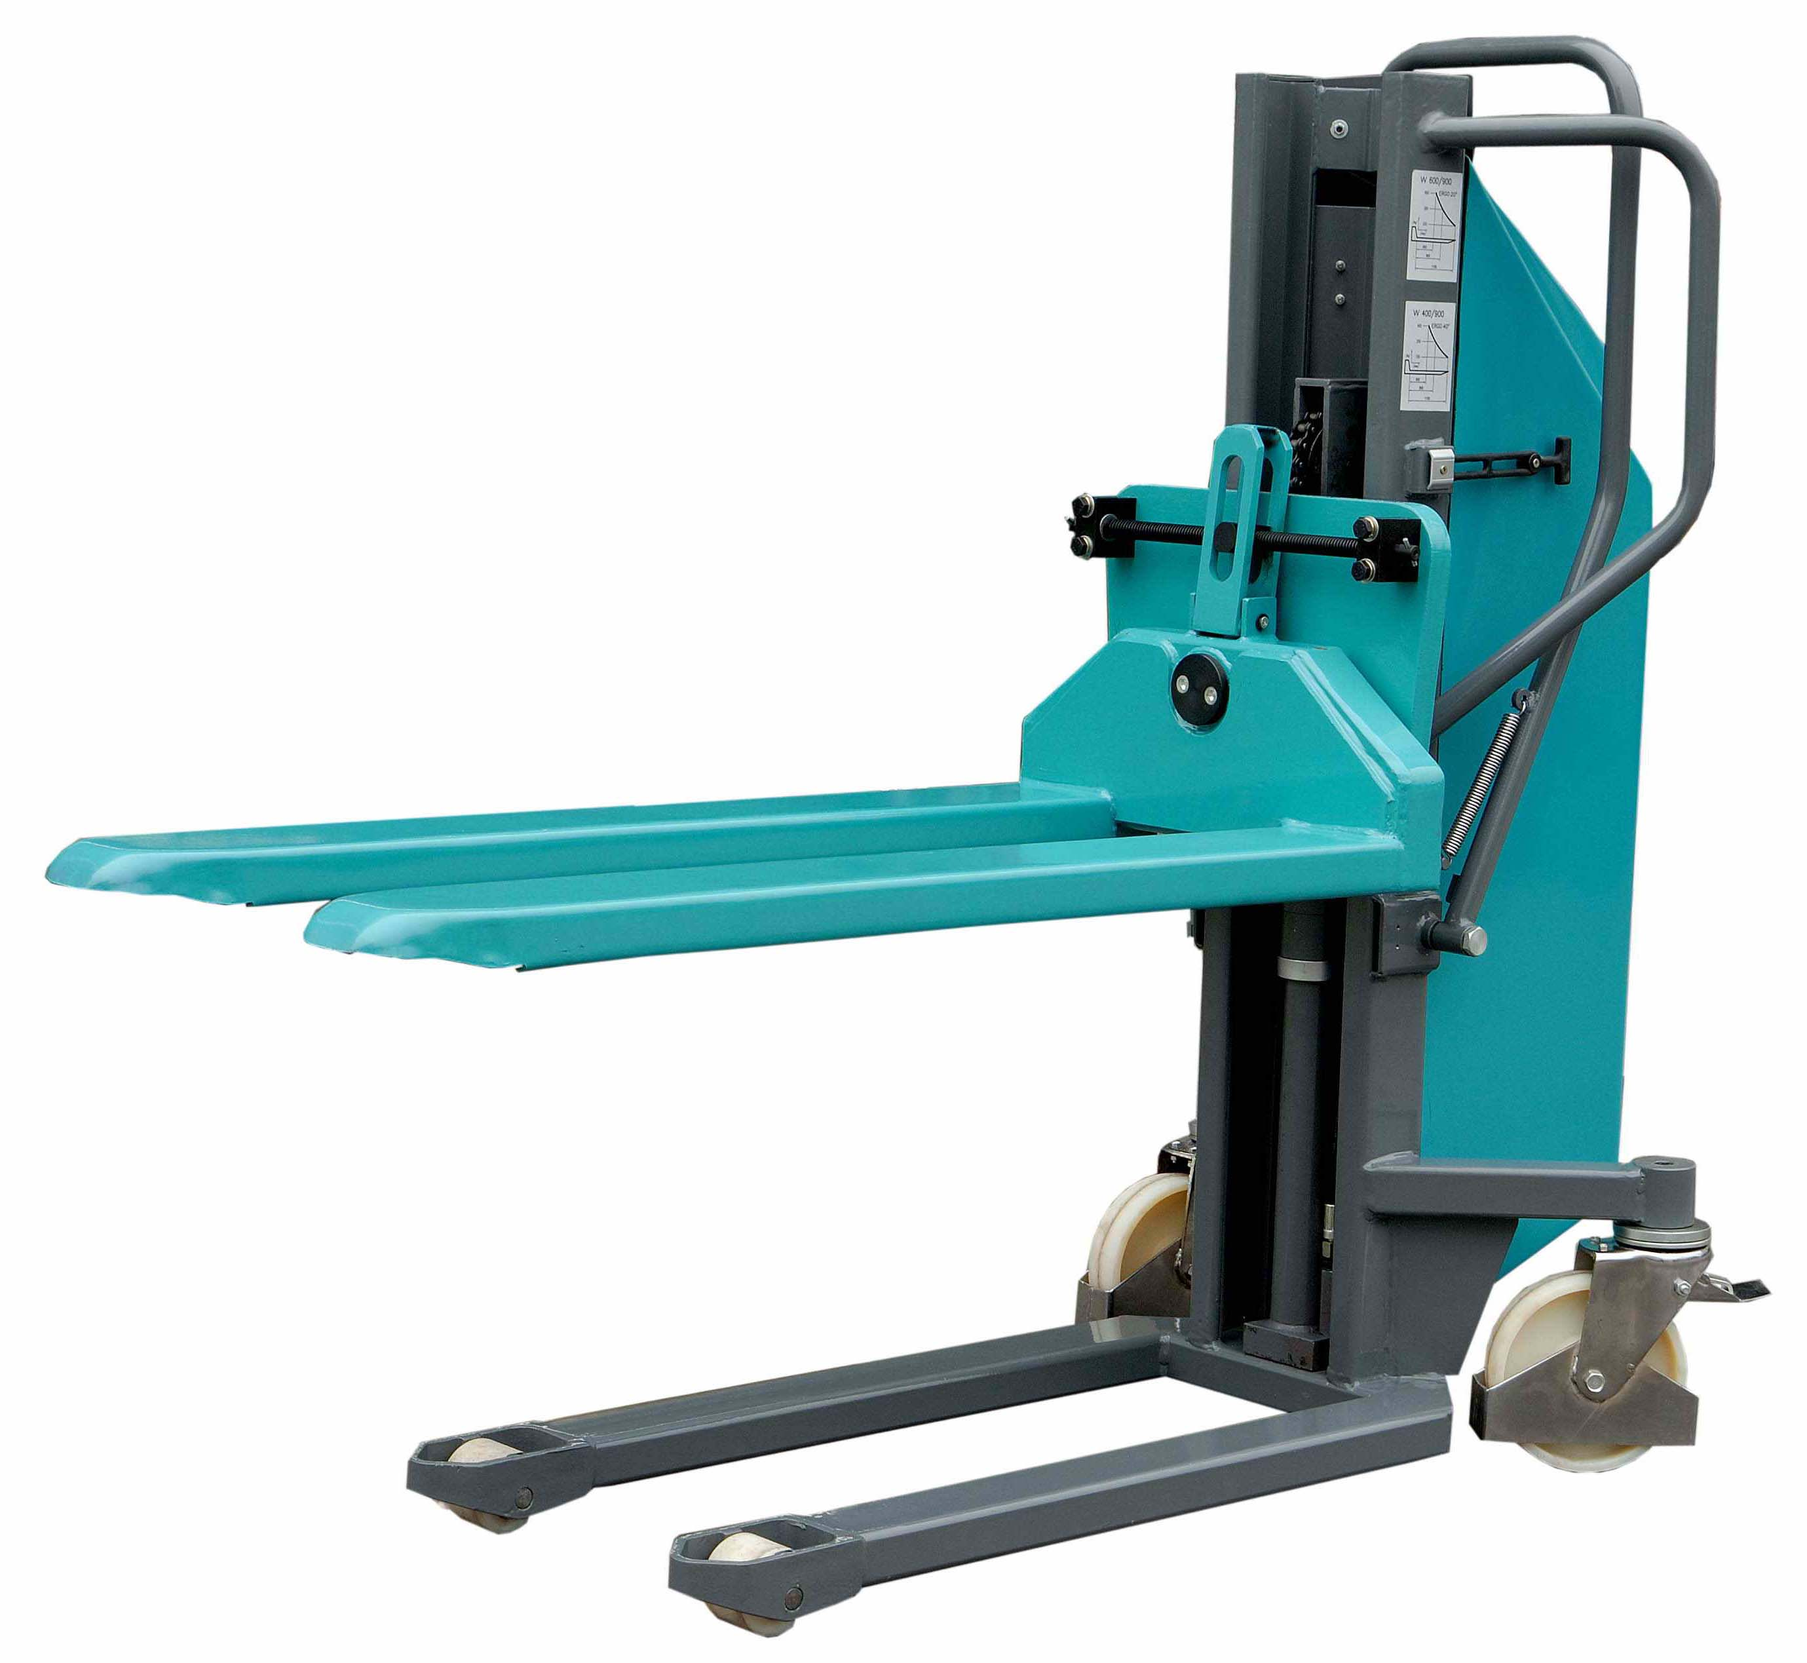
Handle

Tilting forks

Parking brake

Operation and mai ntenance instruction

High Lift Pallet Truck EHS-T0809

Manual high lift truck with electric lifting (later “truck” only) is designed for the transport, handling and stacking of material which is placed on pallets. It enables to offtake and to base pallets to the maximum lifting height of the truck by using electrohydraulic aggregate. It decreases physical strain of person manipulating with material.

 | EHS-T0809
Loading capacity  Length  Width  Height  Length of the forks  Width of the fork  Min. height over the floor  Forks width  Spacing between the forks  Truck weight  Lifting height  Bearing surface of the forks  Forks tilting angle  Lifting speed without load  Lifting speed with load  Lowering speed with a load  Clearance above floor  Traction Accu. battery  Electro hydraulic aggregate | 800  1690  730  1420  1140  150  87  540  240  275  900  1140x540  ±20  ≥0.05  ≥0.07  ≥0.045  30  2x12V/ 60Ah  12 V, 700W | kg  mm  mm  mm  mm  mm  mm  mm  mm  kg  mm  mm  °  m/sek  m/sek  m/sek  mm
Technical data
Constrution description

The truck consits from the outer frame, the internal frame, the working cylinder, the hydraulic aggregate, forks and the handle. The forks are lifted by chain anchored to the outer frame, which is pushed by a piston rod of the working cylinder. The opposite end of the chain is mounted to the forks. The offtaking of the piston rod is provided through the pressure of hydraulic oil created by hydraulic aggregate. The aggregate is activated by pressing of the push-button up and down. Wheels rotation angle is 360°, each of the wheel is equipped with a brake.

These parts are installed in the electric circuit:
- electric fuse for the power circuit
- electric fuse for the control circuit
- connector socket for connecting a charger

There is the throtting valve mounted within the hydraulic circuit.

Electrohydraulic unit
Flow  Tank  Engine output  Intensity | 0.75ml / rev  1L  700 W  12 V  2 x 12V / 60Ah  min. 1500  min. 100 lift

Source
Traction battery
Amount of charging cycles
Lifts/1 charging cycle

Instructions to the truck usage

Oil check and filling

Truck´s working cylinder is filled with hydraulic oil RENOLIN HV - 32. If the truck is used daily, it is recommended to check oil level 1x a month. There is right amount of oil, if there is minimum amount of oil in the tank, while the forks are in the highest position. When filling hydraulic block with oil, it is necessary to filter it through 25 μm filter.

Battery control

It is necessary to control battery regularly with an equipment for measuring of electrolyte density. It is recommended, when electrolyte density is below 75 % of nominal value, to recharge the battery, so it will be not depriciated. Clean and use the battery according to the battery´s instruction manual.
Always charge the battery by chargers, which refer to listed specification of required battery. A charger is delivered as extra.

Lowering speed adjusting

In hydraulic circle, on the plate of hydraulic cylinder there is a throtle valve assembled, by which the speed of forks lowering is set. In case, that it is necessary to change the speed of lowering, it is possible to order throtting valve with regulation screw on it (see the picture “Connecting and gripping of hydraulic unit EHS”), which can be used for speed changing.

Operation manual

This truck can be operated by a worker older than 18 years of age, who is mentally and physically suitable and knows all safety regulations regarding material handling using trucks with electric lifting and operation. Operation of the stacker is assured through two buttons.

Lifting

Forks lifting is performed by using a press button where there is an “LIFT” arrow marked.This switches the electrohydraulic engine, which causes forks lifting.

Load transport

When neither of the press buttons is pressed, the forks are in the neutral position. The load is held in any position, which is provided by a non-return valve in hydraulic circuit. Load transport is allowed when the forks are not higher then 200 mm above the floor.

Lowering

By pressing the press-button where there is an “LOWER” arrow marked, the valve is opened and the forks are being lowered to their lowest position. Their lowering speed is regulated by the throttle valve.

Loading diagram EHS-T0809

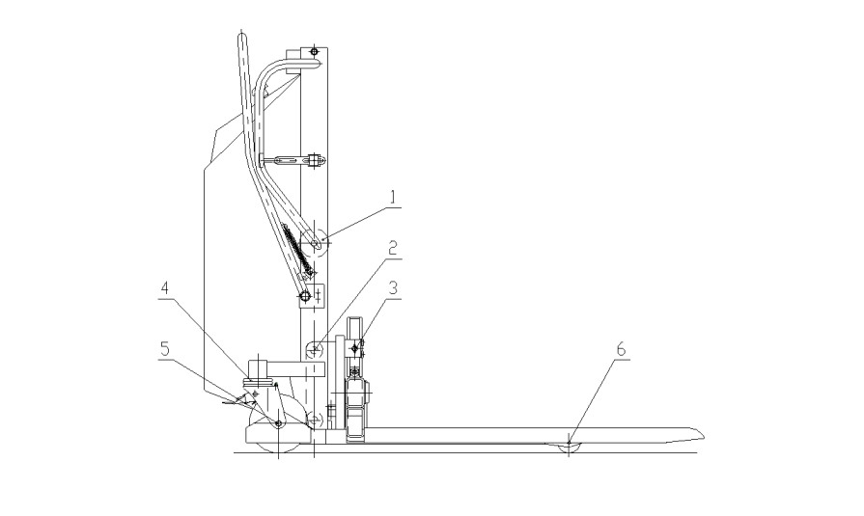
Lubricating plan

Pos.  No. | Place of lubrication | No. of places  HS-T0809 | Lubricant  type | Lubricant  quantity | Interval
1  2  3  4  5  6 | Chain wheel bearing  Forks bearing  Helix  Front wheel bearing  Front wheel bearing  Rear wheel bearing | 1  4  2  2  4  4 | T – K3  T – V2  T – V2  T – V2  T – V2  T – V2 | 0,01 kg  0,005 kg  0,005 kg  0,005 kg  0,005 kg  0,005 kg | Twice a year  Once a year  Once a year  Once a year  Once a year  Once a year

Safety regulations

When handling loads, operational procedures, which protect operators from accidents and injuries, must be used. These are mainly caused by incorrectly secured loads, by exceeding the max. load capacity, or by sliding of the truck on poor transport surfaces. Doorsills and other similar obstructions must be leveled by means of ramps as well as bridges between neighbouring floors.

It is forbidden:

- to use the truck for handling on inclined surfaces
- to perform any repairs and maintenance on a truck carrying a load
- to handle loads with a center of gravity higher than 500 mm
- to transport the loads while lifted higher than it is specified 200 mm over the ground except
technologically essential transport

Note:
- technologically essential transport isofftaking and placing of the load in the place of stacking.

It is necessary:
- to keep the loading diagram while manipulating with load, which is sticked on each stacker.

Product disposal

The user of product is after the end of technical life obligatory:

- to drain the hydraulic system and to hand an oil over for recycling
- to hand over all metal parts for recycling
- to put all plastic parts into communal waste system

Diagram of electric circuit
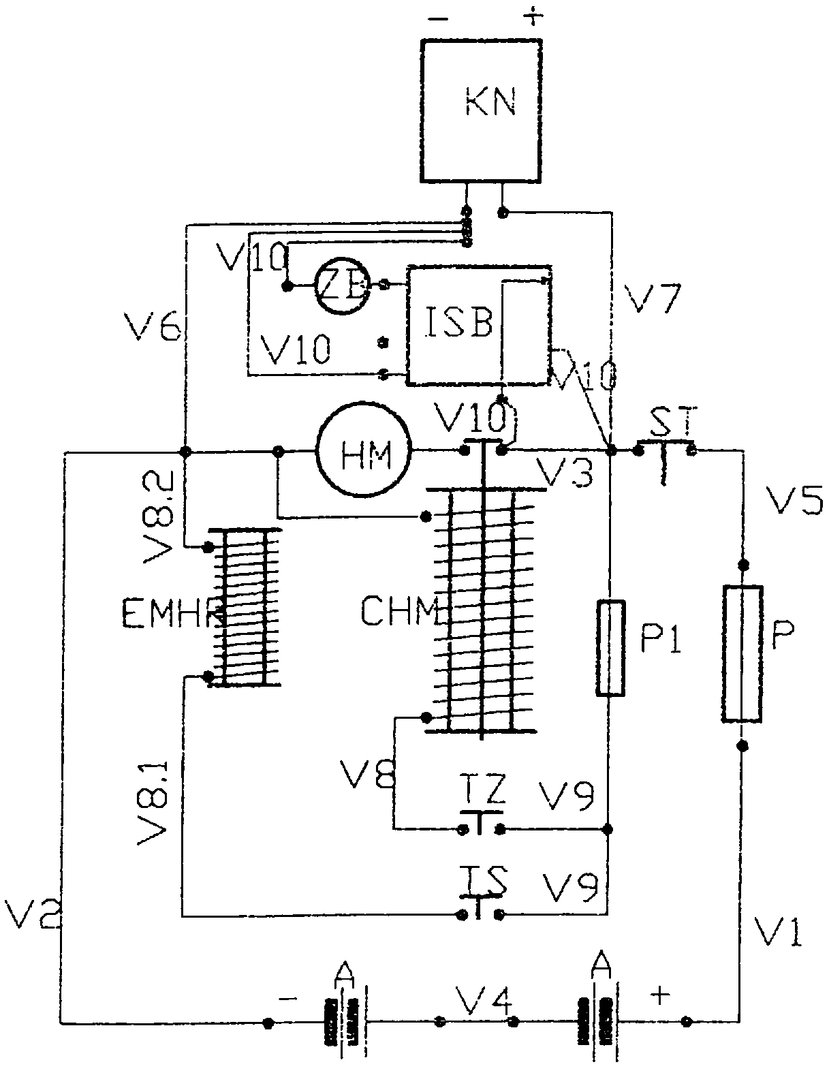

KN - power connector
ZB - back up battery
ISB - accumulator indicator
HM - hydromotor
ST - stop button
P - fuse 160 A
CHM - hydromotor coil
MS - microswitch
A - accumulator
P1 - fuse 6,3 A
EMHR - hydromotor electromagnet
TZ - lifting button
TS - lowering button
V1-V10 - conductors

Connection and gripping of hydraulics for EHS
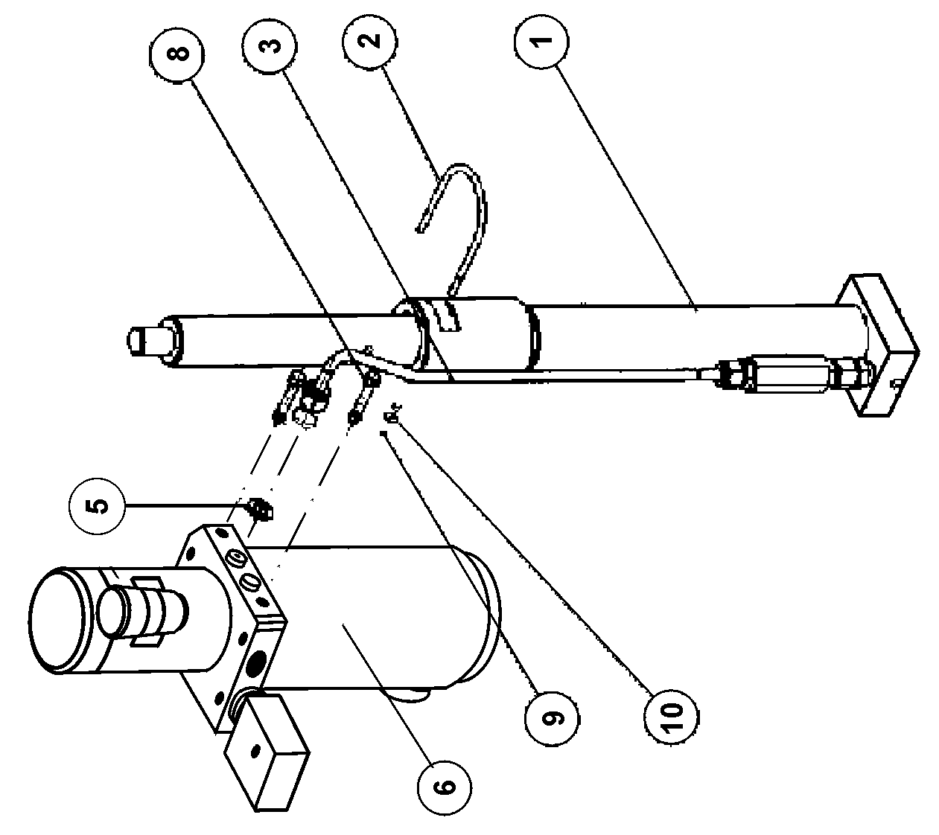

Connection and gripping of hydraulics for EHS | Note
Connection and gripping of hydraulics for EHS | Pcs | 1  1  1  2  1  2  2  2
Connection and gripping of hydraulics for EHS | Description | Working cylinder – ass.  Clamp  Compression hose  Straight hub  Hydraulic aggregate  option – hydraulic aggregate  Screw M10x35  Nut M6  Washer φ6,3
Connection and gripping of hydraulics for EHS | Pos. | EHS101  EHS102  EHS103  EHS105  EHS106  EHS108  EHS109  EHS110
Connection and gripping of hydraulics for EHS | NO. | 1  2  3  5  6  8  9  10

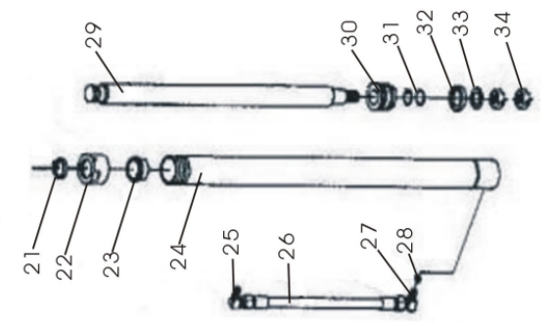
Working cylinder assembly for EHS

No. | Name | Quantity
21 | Dust ring | 1
22 | Nut | 1
23 | Stop Collar | 1
24 | The hydraulic cylinder | 1
25 | Tubing connector | 1
26 | Tubing | 1
27 | Tubing connector | 1
28 | Gasket | 4
29 | Rod | 1
30 | Piston | 1
31 | O-Seals | 2
32 | Oriented band | 1
33 | Seals | 1
34 | Nut | 1

Tilting forks

Tilting forks | Note
Tilting forks | Pcs | 2  2  2  4  4  4  1  2  2  1  1  1  1  1  2  1  4  1  1  4  4  4  8  4
Tilting forks | Description | Washer  Bearing  Trapezium screw holder  Plane washer 12  Spring washer 12  Screw M12x80  Fork arm pin  Snap ring 9  Cotter 5x30  Trapezium screw M20x4  Fork arm – welded  Trapezium screw stone  Washer  Push cover  Bolt  Tilting forks – welded  Bolt M5x8  Tie plate  Fork carrier – welded  Roller  Bearing  Snap ring 25  Washer 10  Pole
Tilting forks | Pos. | HS201T  HS202T  HS203T  HS204T  HS205T  HS206T  HS207T  HS208T  HS209T  HS2010T  HS2011T  HS2012T  HS2013T  HS2014T  HS2015T  HS2016T  HS2017T  HS2018T  HS2019T  HS2020T  HS2021T  HS2022T  HS2023T  HS2024T
Tilting forks | No. | 1  2  3  4  5  6  7  8  9  10  11  12  13  14  15  16  17  18  19  20  21  22  23  24

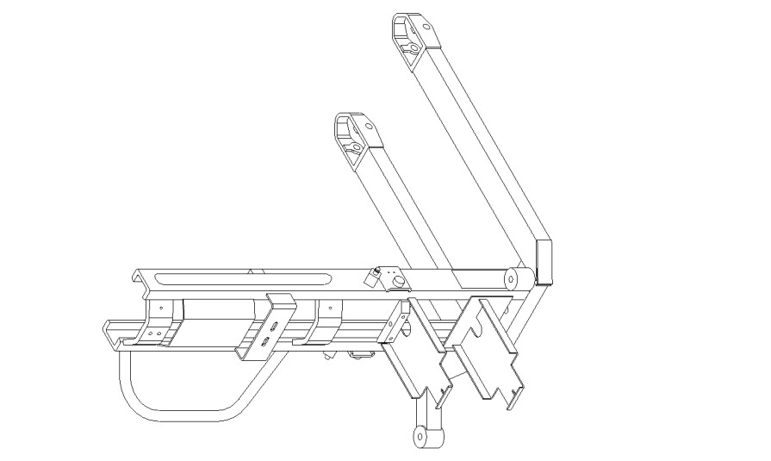

Frame – welded EHS-T0809

Frame – welded EHS-T0809 | This frame is welded by using more parts, which are comprised into one indemountable unit.

