Instruction Manual
Stainless steel
Scissor Lift Pallet Truck
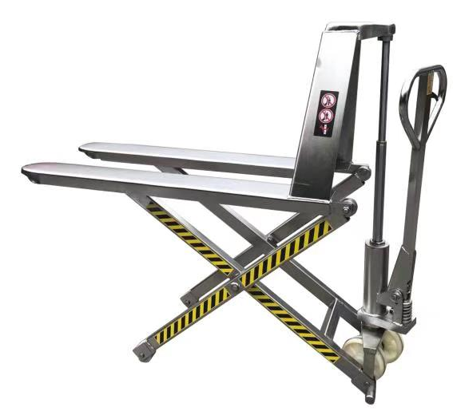

Note: Owner/Operator must read and understand this instruction
Manual before using the Scissor Lift Pallet Truck

Pump Of HPTAS
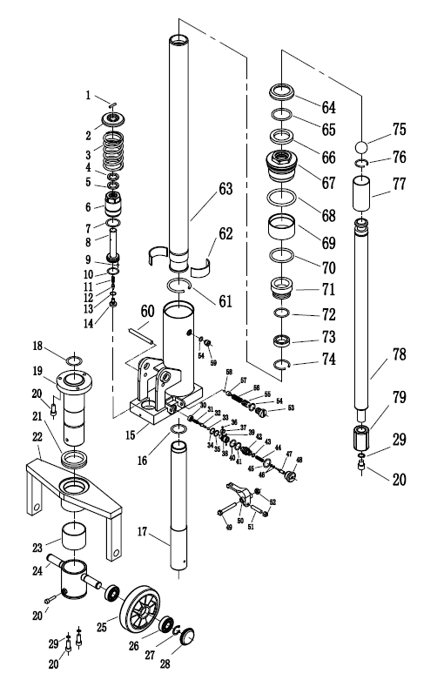

PART NO. | DESCRIPTION | QTY | PART NO. | DESCRIPTION | QTY
1 | PIN | 1 | 47 | Release indicator | 1
2 | SPRING CAP | 1 | 48 | Valve nut | 1
3 | SPRING | 1 | 49 | SCREW | 1
4★ | DUST SEAL | 1 | 50 | CAM | 1
5★ | Y-RING | 1 | 51 | SCREW | 1
6 | PUMP CYLINDER | 1 | 52 | NUT | 2
7 | COPPER WASHER | 1 | 53 | PLUG | 1
8 | PUMP PISTON | 1 | 54 | O-RING | 2
9 | STEEL BALL | 1 | 55 | PLUG | 1
10★ | O-RING | 1 | 56 | SPRING | 1
11 | SPRING | 1 | 57 | VALVE | 1
12 | VALVE | 1 | 58 | STEEL BALL | 1
13★ | O-RING | 1 | 59 | SCREW | 1
14 | SCREW | 1 | 60 | PIN | 1
15 | PUMP HOUSING | 1 | 61 | SNAP RING | 1
16★ | O-RING | 1 | 62 | COPPER PISTON | 2
17 | CYLINDER | 1 | 63 | LIFTING PISTON | 1
18★ | O-RING | 1 | 64★ | DUST SEAL | 1
19 | CYLINDER BUSH | 1 | 65★ | O-RING | 1
20 | SCREW | 7 | 66★ | Y-RING | 1
21 | BEARING | 1 | 67 | CYLINDER HEAD | 1
22 | TABLR | 1 | 68★ | O-RING | 1
23 | SLEEVE | 1 | 69 | OIL BAFFLE SLEEVE | 1
24 | WHEEL YOKE | 1 | 70★ | O-RING | 1
25 | WHEEL | 1 | 71 | BRONZE BUSHING | 1
26 | BEARING | 4 | 72★ | O-RING | 1
27 | SNAP RING | 2 | 73★ | Y-RING | 1
28 | WHEEL CAP | 2 | 74 | SNAP RING | 1
29 | SPRING WASHER | 3 | 75 | STEEL BALL | 1
30 | Cap | 1 | 76 | SNAP RING | 1
31 | Spring | 1 | 77 | STEEL SLEEVE | 1
32 | Release Valve | 1 | 78 | PISTON ROD | 1
33 | Steel ball | 1 | 79 | PISTON | 1
34 | O ring | 1
35 | Seal ring | 1
36 | Screw | 1
37 | Spring | 1
38 | Valve Insert | 1
39 | Pin | 2
40 | O ring | 1
41 | Seal ring | 1
42 | Valve Insert | 1
43 | O ring | 1
44 | Spring | 1
45 | O ring | 1
46 | O ring | 2
Handle Of HPTAS
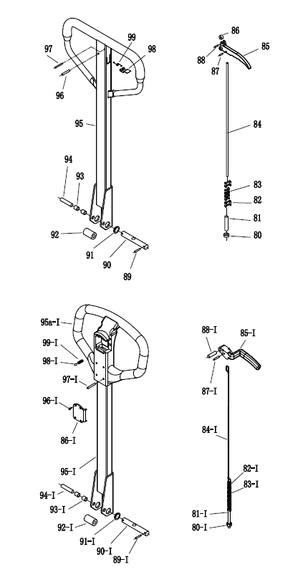
Frame Of HPTAS

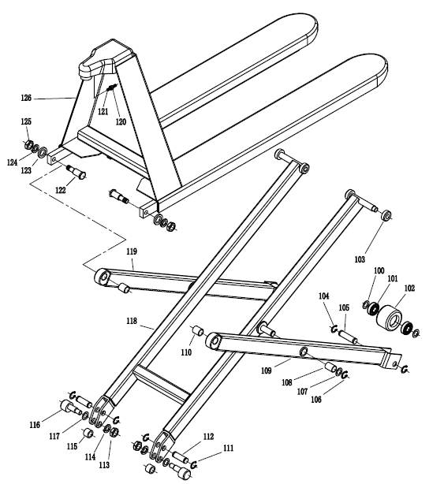

PART NO. | DESCRIPTION | QTY | PART NO. | DESCRIPTION | QTY
80 | Nut | 1 | 100 | WASHER | 4
81 | Screw | 1 | 101 | BEARING | 4
82 | Chain Connector | 2 | 102 | LOAD WHEEL | 2
83 | Chain | 1 | 103 | STEEL ROLLER | 4
84 | Release Rod | 1 | 104 | SNAP RING | 4
85 | Release Lever | 1 | 105 | LOAD WHEEL SHAFT | 2
86 | Roller | 1 | 106 | SNAP RING | 2
87 | Spring pin | 1 | 107 | WASHER | 2
88 | Spring pin | 1 | 108 | BUSHING | 2
89 | Spring pin | 2 | 109 | RIGHT LEG | 1
90 | Shaft | 1 | 110 | BUSHING | 2
91 | Bushing | 2 | 111 | SNAP RING | 4
92 | Roller | 1 | 112 | PIN | 2
93 | Bushing | 2 | 113 | NUT | 2
94 | Pin | 1 | 114 | SPRING WASHER | 2
95 | Handle | 1 | 115 | SPACER | 2
96 | Spring pin | 1 | 116 | CENTRIFUGAL AXLE | 2
97 | Spring pin | 1 | 117 | WASHER | 2
98 | Spring Plate | 1 | 118 | SCISSOR PROJECT | 1
99 | Spring | 1 | 119 | LEFT LEG | 1
80-I | Nut | 1 | 120 | NUT | 1
81-I | Screw | 1 | 121 | SCREW | 1
82-I | Chain Connector | 2 | 122 | PIN | 2
83-I | Chain | 1 | 123 | SLEEVE | 2
84-I | Release Rod | 1 | 124 | SPRING WASHER | 2
85-I | Release Lever | 1 | 125 | NUT | 2
86-I | Cap | 1 | 126 | FORK | 1
87-I | Pin | 1
88-I | Pin | 1 | I | VALVE CPL （30～48）
89-I | Spring pin | 1 | II | PUMP CPL（4～20、30～79）
90-I | Shaft | 1 | III | SEAL CPL SEE★
91-I | Bushing | 2 | Ⅳ | HANDLE CPL （80～99）
92-I | Roller | 1 |  | HANDLE CPL （80I～99I）
93-I | Bushing | 2
94-I | Pin | 1
95-I | Steel Handle | 1
95a-I | Plastic Handle | 1
96-I | Screw | 4
97-I | Rivet | 4
98-I | Steel ball | 1
99-I | Spring | 1

INSTRUCTION

RAISE POSITION
Depress the lever #102（103-I） and pump handle until pallet has reached the desired height.A clearance of-1” between floor and pallet is usually sufficient to move the load. Do not lift load with one fork extremity of forks.

NEUTRAL POSITION
The neutral position is found at about 45”between th raise and lower position.This neutral (drive) position disengages the lifting mechanism making the handle free from hydraulic resistance and becomes almost weightless,yet the forks retain their raised position.Always use the neutral position when moving a load.

LOWER POSITION
Pull the lever up to lower the forks,The lever is spring loaded for lowering only,therefore when you release the level it will automatically return to the natural position.

WARNING
For safe operation of Hand Pallet Trucks.Please read the following instructions:
1.Do not operate a Hand Pallet Truck unless you are familiar with it and have been trained and authorized to do so.Read all warnings and instructions here and on the truck.
2.Do not operate a Hand Pallet Truck until you have checked its condition.Give special attention to the wheels,handle,forks,lifts and lower control,and brakes (if so equipped).Do not operate damaged or faulty trucks.Do not attempt repairs unless you are trained and authorized to do so.
3.Operate Hand Pallet Trucks only from the designated operating positon.Never place any place any part of your body in the lifting mechanism or under the forks or load. Do not carry passengers.
4.Do not handle unstable or loosely stacked loads.Use special care when handling long,high or wide loads to avoid losing the load,striking by standers,or tipping the truck.
5.Do not overload the truck.Check capacity plate for carrying capacity information.Overloading may cause truck to perform incorrectly.
6.The capacity of tile truck assumes an evenly-distributed load with the center of the load being at the halfway point of the length tile forks.
7.Make sure that length of tile forks match the length of the pallet.Using a pallet truck where the forks are longer than the pallet will damage the truck of the pallet truck is pushed through the pallet and the forks are under a second pallet behind the one being lifted.When lowering the load,make sure the area where the pallet is to places is clear.
8.Observe traffic regulations.Yield rigth of way to pedestrians,Stop at cross aisles.
9.Hand Pallet Trucks are for general operation on level,flat hard surfaces.If ramps are encountered,the optional hand brake can be ordered,or the truck may be stopped in emergencies by operating the lowering control,which will lower load to the ground,stopping tile truck.If the truck has to be stopped in this manner,care should be taken so that no part of your body is near or under the load. It is important not to operate a Hand Pallet Truck on a grade with loads that are too heavy to be easily handled by the operator.Since these are manually operated trucks,they are not to be used by operators that are not physically capable of safely handling the trucks with a load.
FAILURE TO FOLLOW THESE INSTRUCTIONS MAY CAUSE SERIOUS INJURY TO THE OPERATOR OR OTHERS.

THREE-MONTH MAINTENANCE SCHEDULE
- Check oil level
- Lubrication-Jouints,pins,axles,push rods,Steering Wheel’s and Load Roller’s Bearings with good molybdenm type grease.

ORDERING PARTS
HPTA pallet trucks are distributed through a sales organization that is eager and capable to service the equipment it has sold you. You will be well taken care or if-whenever parts or repairs are needed-you turn to the source from which you purchased your truck.When doing so “Please be sure to state Model No. and Serial No.”of your truck and use part numbers and nomenclature as shown in parts listing giving in this poster. Adherence to the above procedure will save time and provide speedy assistance when it counts.

