PTE15N SC
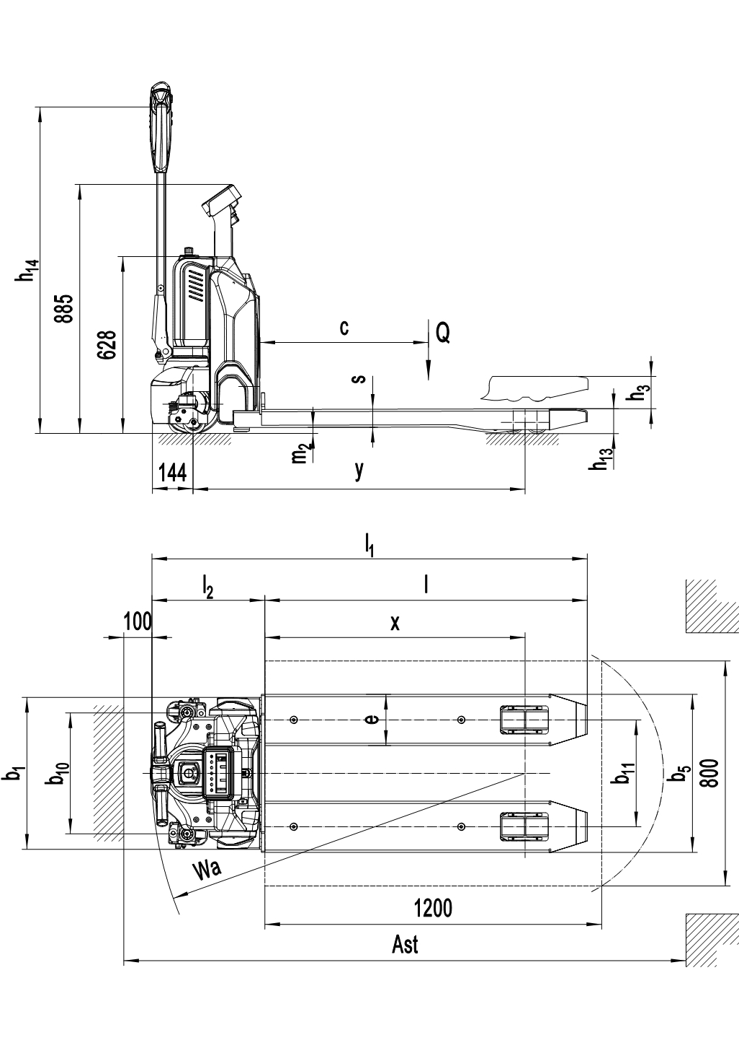

 |  | Type sheet for industrial truck acc. to VDI 2198
Distinguishing mark | 1.2 | Manufacturer`s type designation |  | PTE15N SC
Distinguishing mark | 1.3 | Drive |  | Battery
Distinguishing mark | 1.4 | Operator type |  | Pedestrian
Distinguishing mark | 1.5 | Load Capacity / rated load | Q (t) | 1.5
Distinguishing mark | 1.6 | Load centre distance | c (mm) | 600
Distinguishing mark | 1.8 | Load distance ,centre of drive axle to fork | x (mm) | 928
Distinguishing mark | 1.9 | Wheelbase | y (mm) | 1183
Weight | 2.1 | Service weight | kg | 180 | 185
Weight | 2.2 | Axle loading, laden front/rear | kg | 472/1208 | 476/1209
Weight | 2.3 | Axle loading, unladen front/rear | kg | 121/59 | 121/64
Tyres, chassis | 3.1 | Tires |  | Polyurethane (PU)
Tyres, chassis | 3.2 | Tire size,front | ∅ x w (mm) | ∅ 210×70
Tyres, chassis | 3.3 | Tire size,rear | ∅ x w (mm) | ∅ 80×93(∅ 80×70)
Tyres, chassis | 3.4 | Additional wheels(dimensions) | ∅ x w (mm) | -/∅ 80×30
Tyres, chassis | 3.5 | Wheels,number front/rear(x=driven wheels) |  | 1x/ 2(1x/ 4) or 1x +2/ 2(1x +2/ 4)
Tyres, chassis | 3.6 | Tread, front | b₁₀ (mm) | -/430
Tyres, chassis | 3.7 | Tread, rear | b₁₁ (mm) | 380 | 525
Dimensions | 4.4 | Lift | h₃ (mm) | 115
Dimensions | 4.9 | Height of tiller in drive position min./ max. | h₁₄ (mm) | 740 / 1162
Dimensions | 4.15 | Height, lowered | h₁₃ (mm) | 88
Dimensions | 4.19 | Overall length | l₁ (mm) | 1560
Dimensions | 4.20 | Length to face of forks | l₂ (mm) | 410
Dimensions | 4.21 | Overall width | b₁ (mm) | 540
Dimensions | 4.22 | Fork dimensions | s/e/l (mm) | 64 / 182 / 1150
Dimensions | 4.25 | Distance between fork- arms | b₅ (mm) | 562 | 707
Dimensions | 4.32 | Ground clearance, centre of wheelbase | m₂ (mm) | 21
Dimensions | 4.34 | Aisle width for pallets800X1200 lengthways (200mm safe distance) | Ast (mm) | 2000
Dimensions | 4.35 | Turning radius | Wa (mm) | 1387
Performance data | 5.1 | Travel speed, laden/ unladen | km/h | 4.2 4.4
Performance data | 5.2 | Lift speed, laden/ unladen | m/s | 0.015 / 0.022
Performance data | 5.3 | Lowering speed, laden/ unladen | m/s | 0.05 / 0.04
Performance data | 5.8 | Max. gradeability, laden/ unladen | % | 6 / 16
Performance data | 5.10 | Service brake |  | Electromagnetic
Electric- engine | 6.1 | Drive motor rating S2 60min | kW | 0.65
Electric- engine | 6.2 | Lift motor rating at S3 10% | kW | 0.50
Electric- engine | 6.3 | Battery acc. to DIN 43531/ 35/ 36 A, B, C, no |  | No
Electric- engine | 6.4 | Battery voltage, nominal capacity K5 | V / Ah | 24 / 20(24 / 30；24 / 36)
Electric- engine | 6.5 | Battery weight | kg | 4.6
Electric- engine | 6.6 | Energy consumption acc. to VDI cycle | kWh/h | 0.19
Addition data | 8.1 | Type of drive control |  | DC speed Control
Addition data | 8.4 | Sound level at driver`s ear acc. to EN 12053 | dB(A) | <70

