SP800/SPA 800 Hydraulic Lift Table

- Operation manual
- Spare parts catalogue

Original instruction

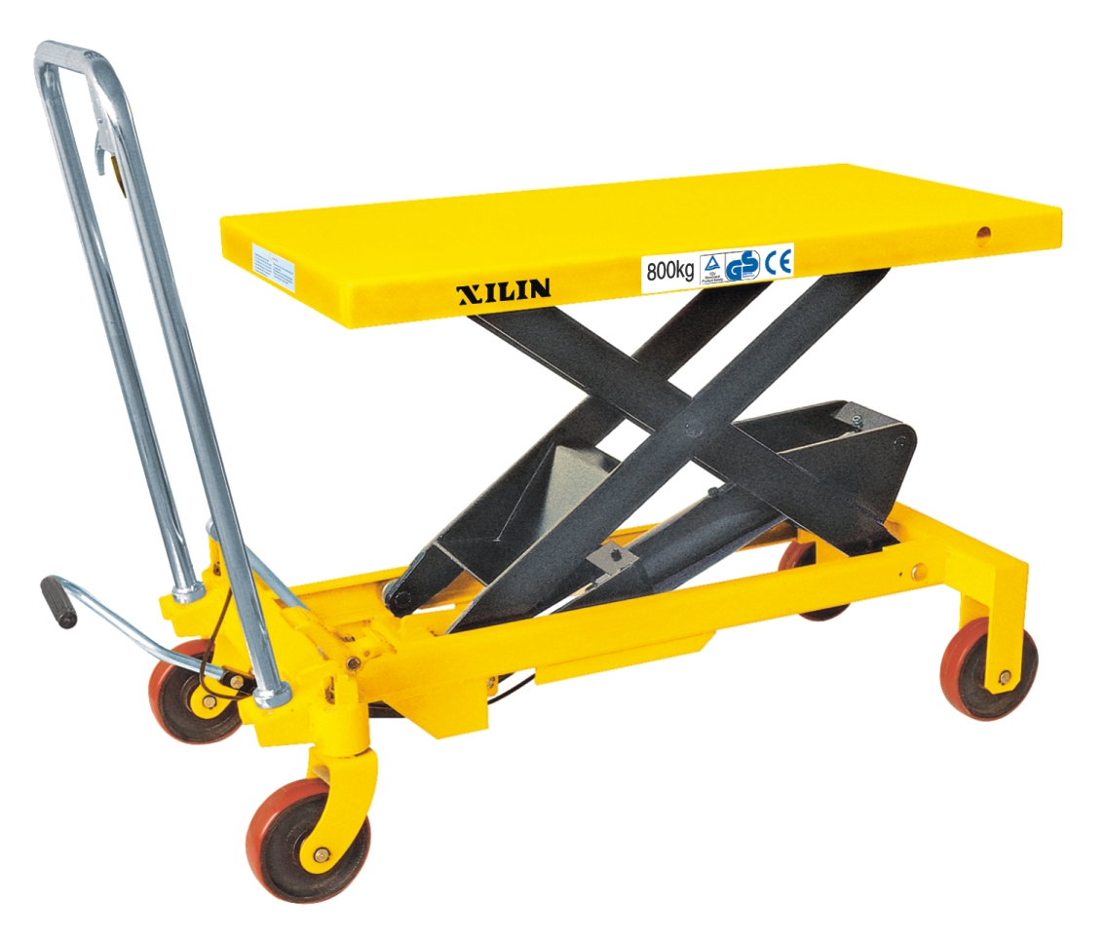

Ningbo Ruyi Joint Stock Co.,Ltd
656 North Taoyuan Road, Ninghai 315600,Zhejiang,P.R. China

 EC Declaration of Conformity
according to the Machinery Directive 2006/42/EC
For the following equipment: :
Product : Scissor Lifting Table
Type Designation /Trademark : SP800/ SP A 800
Manufacturers Name : Ningbo Ruyi Joint Stock Co., Ltd.
Manufacturers Address : 656 North Taoyuan Road, Ninghai, Zhejiang 315600, P.R. China
Refer to in this declaration conforms with the following directive(s):
Machinery Directive 2006/42/EC

The company named above will keep on file for review the following technical documentation :
- Operating and maintenance instructions
- Technical drawings
- Risk assessment
- Description of measures designed to ensure conformity
- Other technical documentation ,e.g. quality assurance measures for design and production

I. Configuration diagram
II. Main technical parameters：
Specification / Model | SP800(A)
Capacity kg | 800
Max. lift height H mm | 1000
Min. height of table h mm | 420
Table size mm | 1000×510×55
Handle height A mm | 996
Overall length B mm | 1150
Foot pedal cycles to max. height | ≤70
Wheel diameter D mm | 150
Working volume of oil cylinder ml | 207
Oil capacity ml | 300
Service weight kg | 115
noise level dB | <70
III. Scope of application：
SP series table lift truck is a kind of high-lift transportation tool which is applicable for short-distance transportation as well as goods lifting and lowering. Besides, it can also be used as station facilities for workshop.
IV. Operation condition:
1. Lift table should be operated on solid and flat ground；
2. Operation temperature: -20-40C°.
V. Notes(warning)：
1. Read the instruction carefully before operation and get to know the performance and operation requirements of the lift table. And the hydraulic lift table can’t be used unless it is authorized.
2、Should wear laborsuit、safety shoes and glove when operating.
3、Ensure to operate safety ,please purchase the accessories by appointed supplier and manufacturer.
4、Should test the truck again after heavy repair and replace the critical pieces in order to make sure the safety.
5、Only the qualified staff can use and operate the truck.
6. Do not overload the hydraulic lift table and operate it within the rated load. Overloading will cause damage to the hydraulic lift table and human body.
7. It is forbidden for operators to stand or sit on the table to work.
8. Don’t put the hands or feet under the lowering table.
9. Please brake the truck when loading goods to prevent it from moving.
10. Off-set loading is forbidden when loading goods, and the goods should be distributed uniformly on the whole table.
11. Loose or unstable goods are not permitted to be loaded.
12. Don’t put goods on working table for a long time.
13. The truck can’t be moved when goods are being lifted.
14. The truck can only be moved on flat and hard ground, it is forbidden to be used on sloping ground or rugged ground;
15. When putting goods on table which has been hoisted, the weight of goods should be within rated load, and the goods should be loaded lightly. (Safety valve only works in hoisting process, if the truck has been hoisted, and then put overweight goods on it, the safety valve can’t work. In this way, the truck may be damaged.)
16. When loading and unloading goods on hoisted table, don’t drag goods in cross direction, which may cause serious off-set loading and make truck turn over.
17. When maintaining and repairing truck, stand bar should be used to support fork arm in order to prevent table from falling (there should be no goods on table), and guarantee the safety in maintenance and repairing.
18. Please operate strictly according to “notes (warning)”, otherwise it will bring damage to truck and human body.
VI. Operation methods：
1. Please step on the foot lever for several times to raise the working table.
2. Please lift the handle knob upward slowly, and open the one-way valve to make the working table descend slowly.
3. Please make the brake open before moving the truck.
4、Braking operation：
- It was forbidden to use braking when the truck is operating lift and fall at the same time. It was also forbidden to put the feet and any parts of body to the brake position.

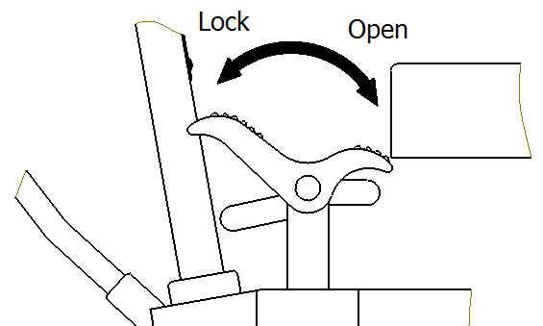

Brake pedal

VII. Maintenance and upkeep:
It is very important to conduct necessary maintenance and upkeep so as to prolong the service life and safety of the lift table. Please check the lift table before operation according to the following items:
1. Whether there is any distortion and bending of various positions of the lift table.
2. Please check the brake of the truck and the wearing condition of the wheels.
3. Check oil leakage in the hydraulic system.
4. Please add or fill lubricant to each friction surface before daily operation.
5. If there is any failure, the lift table should be repaired at once, and any replacement parts required for the lifting table shall be obtained from the original manufacturer of the lifting table or be of at least equivalent quality and safety, then it can be put into use again.
6. Chang the hydraulic oil every twelve months, choose the following or close brand hydraulic oil according to the climate conditions of different areas:
a) YBN32 is adaptive under the environment temperature of -10~+40°C;
b) YCN32 is adaptive under the environment temperature of -20~+40°C.
7. Hydraulic oil change methods:
a) screw out the sealing screw 11of the attached drawingⅡwith wrench;
b) raise the hand knob;
c) twist off screw 36 of the oil plug and fill in hydraulic oil.
8. No.1, no.3, no.4, no.21, no.29, no.32, no.40, no.43, no.47, no.48, no.33, no.41, and no.45 of attached drawing Ⅱ are seal components of rubber, polyurethane and nylon. The general keeping time is two years. If exceeding the time limit, it will be aging and this will affect the service performance. If so, please change it in time.
9. When a major repair has been carried out the lifting table shall be re-tested.

VIII. Trouble shooting methods
Faults | Causes | Trouble shooting
The truck can not be raised or the lifting height is not enough. | 1) Steel ball (23) of the check-valve is not closed down.  2) Firing pin (28) withstands the steel ball (16).  3) Short of hydraulic oil. | 1) Clean the valve opening and change the steel ball (23).  2) Adjust the tension rate of the steel wire rope to make firing pin at suitable place, and add or fill lubricant to the pin roll（30）  3) Add enough hydraulic oil.
The table-board rises then descends. | - Steel ball (23)(24)(16) of the check-valve is not closed down.  2) Firing pin (28) withstands the steel ball (16). | 1) Clean the valve opening and change the steel ball (23) (24) (16).  2) Adjust the tension rate of the steel wire rope to make firing pin at suitable place, and add or fill lubricant to the pin roll（30）
The table-board does not descend | The travel of the firing pin (28) is not enough to open the steel ball (16). | Adjust the tension rate of the steel wire rope to make firing pin at suitable place, and add or fill lubricant to the pin roll（30）
Oil leakage at firing pin. | The O-type seal ring (29) is damaged. | Change the O-type seal ring (29).
Oil leakage at pump (2), pump core (5) and piston rod (44). | The seal ring (1)(3)(47)(48) are damaged. | Change the seal ring (1)(3)(47)(48)
IX. Assembly method：
The handle and foot lever of SP300A，SP500A，SPS150，SPS150A，SPS350，SPS350A type lift table is dismantled when ex-factory, they might be fixed together by the users when using. The assembly methods are as follows:
Handle installation method: according to the developed drawing, fix the handle (1) to mounting hole of the truck body (18) with bolt (64), spring washer (63), flat washer (62), then screw down the bolt (64) with wrench.
Foot lever mounting: insert the foot lever (47) into the hole of the square bar (60), screw in the screw (42), then put in the plain washer (6) and the spring washer (11) respectively and screw down the nut (12).
X. Structure diagram and principle diagram
See the principle diagram of the hydraulic system in the attached drawing (3)

Attached drawing (2)

Attached drawing (1)

Oil pump
Working cylinder
One-way valve
Throttle valve
One-way valve
Safety valve
Unloading valce
Oil reservoir

Principle specification
- The restriction chock and the constant pressure overflow valve leak oil at the same when no-load, the no-load vehicle descend faster, and it can meet the customers the demand。
- When the load is more than 50kg, the system pressure is 8MPa, the constant pressure overflow valve closes automatically, the hydraulic oil leaks through the restriction chock, the vehicle descend slowly, and this agrees with the safety standards.

Attached drawing（3）
Spare Parts Catalogue

1. Explosive drawing and parts list of handle
2. Explosive drawing and parts list of SP700/SP800/SP800A pump
3. Explosive drawing and parts list of SP700/SP800 assembly
4. Explosive drawing and parts list of SP800A assembly

Explosive Drawing and Parts List of Handle

No. | Drawing no | Description | Qty | Remark
1 | GB879-86 | Pin 6x30 | 1
2 | SPAⅢ.1.01 | Handle bar | 1
3 | SPⅢ.1.02 | Handle | 1
4 | GB6172-86 | Nut M8 | 1
5 | SPⅢ.0-01 | Screw | 1
6 | 1510(1240) | Pull rod | 1
Remark : The handle of SP800A with fender.

Explosive drawing of SP800/SP800A pump

Part No.26 can be made as the pressure measure interface of the system.

Spare parts list of SP800/SP800A pump

No. | Drawing no | Description | Qty | Remark | No. | Drawing no | Description | Qty
1 | GB3452.1-86 | O-ring 22.4x2.65 | 1 |  | 25 | GB308-77 | Steel ball 1/2(12.7) | 1
2 | SP.8-11 | Pump cylinder | 1 |  | 26 | GB77-85 | Screw M16x18 | 1
3 | UHS18 | YX-Seal ring | 1 |  | 27 | YQ-01A | Strike pin | 1
4 | DH18 | Dust ring | 1 |  | 28 | GB3452.1-82 | O-ring 6.9x1.8 | 2
5 | SP.8-10 | Pump plunger | 1 | SP70.6-05 | 29 | DF1.2-08 | Shaft | 1
6 | SP.8-09 | Spring | 1 |  | 30 |  | Filter | 1
7 | SP.8-08 | Spring seat | 1 |  | 31 | GB3452.1-82 | O-ring 77.5x3.55 | 2
8 | GB894.1-86 | Retaining ring for axle 10 | 1 |  | 32 | SP70.6-06 | Rectangular section ring | 1
9 | SP70.0-09 | Joint plate | 2 |  | 33 | SP70.6-03 | Cylinder | 1
10 | SP.0-14 | Pin | 1 |  | 34 | SP70.6-02 | Housing | 1
11 | JF.1-17 | Screw | 1 |  | 35 | SP.8-02 | Screw | 1
12 | JB982-77 | Copper washer 20 | 1 |  | 36 | GB894.1-86 | Retaining ring for axle 25 | 1
13 | 6W804.1-12 | Damp valve | 1 |  | 37 | SP70.6-07 | Washer | 1
14 | YQ-03A | Spring | 1 |  | 38 | GB3452.1-82 | O-ring 41.5x4.6 | 1
15 | YQ-02 | Spring seat | 1 |  | 39 | SP70.6-08 | Cup packing | 1
16 | GB308-77 | Steel ball 6.35 | 2 |  | 40 | SP70.6-09 | Bush | 1
17 | GB308-77 | Steel ball 4.5 | 1 |  | 41 | GB3452.1-82 | O-ring 20x2.65 | 1
18 | SP.8-18 | Spring seat | 1 |  | 42 | SP70.6-04 | Piston rod | 1
19 | SP.8-17 | Spring | 1 |  | 43 | S70.6-01 | Cylinder cap | 1
20 | SP.8-16 | Adjusting screw | 1 |  | 44 | GB3452.1-82 | O-ring 31.5x3.55 | 1
21 | GB3452.1-86 | O-ring  7.5x2.65 | 2 |  | 45 | HG4-692-67 | J-shaped steel frame rubber sealing 32x45x6.5 | 1
22 | SP.8-15 | Cover ring | 1 |  | 46 | YQ.6-700 | Base | 1
23 | GB308-77 | Steel ball 9.5 | 1 |  | 47 | YQ-04 | Lever plate | 1
24 | SP.8-07 | Spring | 1 |  | 48 | GB894.1-86 | Retaining ring for axle 8 | 1

Explosive Drawing of SP800 assembly

Part No.22 can be made as the pressure measure

Spare parts list of SP800 assembly

No. | Drawing no | Description | Qty | No. | Drawing no | Description | Qty
2 | SPAⅢ.1.01 | Handle bar | 1 | 27 | GB5781-2000 | Bolt M8x12 | 1
3 | SP70.0-15 | Rod | 1 | 28 | SP70.0.02 | L-pin | 1
4 | SP70.0-14 | Cam | 2 | 29 | SP70.3-00 | Frame | 1
5 | SP70.0-13 | Retaining ring | 1 | 30 | YQ-00-700 | Pump | 1
6 | SP70.0-12 | Pedal | 1 | 31 | SP.0-11 | Shaft | 1
7 | GB77-85 | Screw M8x20 | 3 | 32 | SP.0-12 | Bush | 1
8 | GB41-86 | Nut M8 | 4 | 33 | GB894.1-86 | Retainingring for axle 10 | 1
9 | SP70.0-11 | Nut | 4 | 34 | GB70-85 | Screw M8x10 | 1
10 | SPA.0-02 | Washer | 4 | 35 | GB93-1986 | Washer 8 | 3
11 | GB93-1986 | Washer 12 | 2 | 36 | GB894.1-86 | Retaining ring for axle 20 | 4
12 | GB5781-2000 | Bolt M12x30 | 2 | 37 | YQ-7-700 | Retaining ring | 1
13 | GB/T276-94 | Bearing 105 | 2 | 38 | SP70.0-07 | Shaft | 1
14 | SP70.0-10 | Bush | 2 | 39 | SP70.2.01B | Pedal rod | 1
15 | GB297-64 | Bearing 7205 | 2 | 40 | SP.3-03 | Cushion | 1
16 | GB5781-2000 | Bolt M10x35 | 2 | 41 | GB894.1-86 | Retaining ring for axle 22 | 4
17 | GB41-86 | Nut M10 | 2 | 42 | SPC70.4-13 | Roller | 2
18 | GB95-1985 | Washer 10 | 1 | 43 | GB5781-2000 | Bolt M8x30 | 1
19 | SP70.7-01 | Spring | 1 | 45 | SP70.0-01 | Shaft | 1
20 | SP70.7.03 | Rack of wheel | 1 | 46 | SP70.4-00 | Arm | 1
21 | SP70.7.02 | Brake piece | 1 | 47 | SP70.4-15 | Roller | 2
22 | GB894.1-86 | Retaining ring for axle 17 | 8 | 48 | SP70.5-00 | Table | 1
23 | SP70.0-05 | Shaft | 4 | 49 | SP.3-02/-01 | Pedal bar | 1
24 | SP70.0-04 | Washer | 8 | 51 | GB95-1985 | Washer 8 | 1
25 | GB/T276-94 | Bearing 60203 | 8 | 58 | YQ-8-700 | Retaining ring | 1
26 | SP70.0-03 | Wheel | 4

Explosive Drawing of SP800A assembly

Spare parts list of SP800A assembly

No. | Drawing no | Description | Qty | No. | Drawing no | Description | Qty
2 | SPAⅢ.1.01 | Handle bar with fender | 1 | 27 | GB5781-2000 | Bolt M8x15 | 1
3 | SP70.0-15 | Rod | 1 | 28 | SP70.0.02 | L-pin | 1
4 | SP70.0-14 | Cam | 2 | 29 | SPA70.3-00 | Frame | 1
5 | SP70.0-13 | Retaining ring | 1 | 30 | YQ-00-700 | Pump | 1
6 | SP70.0-12 | Pedal | 1 | 31 | SP.0-11 | Shaft | 1
7 | GB77-85 | Screw M8x20 | 3 | 32 | SP.0-12 | Bush | 1
8 | GB41-86 | Nut M8 | 4 | 33 | GB894.1-86 | Retaining ring for axle 10 | 1
9 | SP70.0-11 | Nut | 4 | 34 | GB70-85 | Screw M8x10 | 1
10 | SPA.0-02 | Washer | 2 | 35 | GB93-1986 | Washer 8 | 3
11 | GB93-1986 | Washer 12 | 2 | 36 | GB894.1-86 | Retaining ring for axle 20 | 4
12 | GB5781-2000 | Bolt M12x30 | 2 | 37 | YQ-7-700 | Retaining ring | 1
13 | GB/T276-94 | Bearing 105 | 2 | 38 | SP70.0-07 | Shaft | 1
14 | SP70.0-10 | Bush | 2 | 39 | SP70.2.01B | Pedal rod | 1
15 | GB297-64 | Bearing 7205 | 2 | 40 | SP.3-03 | Cushion | 1
16 | GB5781-2000 | Bolt M10x35 | 2 | 41 | GB894.1-86 | Retaining ring for axle 22 | 4
17 | GB41-86 | Nut M10 | 2 | 42 | SPC70.4-13 | Roller | 2
18 | GB95-1985 | Washer 10 | 1 | 43 | GB5781-2000 | Bolt M8x30 | 1
19 | SP70.7-01 | Spring | 1 | 45 | SP70.0-01 | Shaft | 1
20 | SPA70.7.01 | Rack of wheel | 1 | 46 | SPA70.4-00 | Arm | 1
21 | SP70.7.02 | Brake piece | 1 | 47 | SP70.4-15 | Roller | 2
22 | GB894.1-86 | Retaining ring for axle 17 | 8 | 48 | SP70.5-00 | Table | 1
23 | SP70.0-05 | Shaft | 4 | 49 | SP.3-02/-01 | Pedal bar | 1
24 | SP70.0-04 | Washer | 4 | 51 | GB95-1985 | Washer 8 | 1
25 | GB/T276-94 | Bearing 60203 | 8 | 58 | YQ-8-700 | Retaining ring | 1
26 | SP70.0-03 | Wheel | 4 | 59 | SPA70.7-02 | Washer | 4

